**Dynamics is a missing link for understanding baseline-microbiota-dependent heterogeneity in dietary responses**

**Abstract.** The end-point responses of prebiotic fiber intervention are highly individualized and their associations with pretreatment gut microbiota have been previously reported. The missing links between baseline microbiota and end-piont heterogeneity are the community dynamics, yet temporal patterns and underlying processes transforming baseline variability to readouts remain poorly understood. Here we administered inulin and resistant starch from maize to adult mice that carry distinct microbiota, and monitored the dynamics of microbiome profiles and short-chain fatty acids (SCFAs) over four weeks. Inulin is more capable of stimulating production of SCFAs than resistant starch. In the majority of mice, inulin induced biphasic changes in SCFAs concentration and microbiota biodiversity, both of which were quickly perturbed in short-term but only partially recovered even under sustainable inulin supply. We further identified a consortium of five inulin responders that collectively shape short-term microbiota dynamics through an activation-then-competition mechanism. The obsevered dynamical responses depend on baseline microbiota and the baseline-dependency was found in 10%-20% bacterial species and the majority of SCFAs. In accordance with previous human studies, the baseline-specific feature poses a great challenge to extrapolate prediction of SCFA concentration from gut microbiota to unobserved baseline composition. Our study reveals time- and baseline-dependency of dietary fiber responses as major challenges for attainable and robust personalized nutritional therapies.

Keywords: mouse, dietary fiber intervention, gut microbiome, time-series, dynamics, short-chain fatty acids, ecological network, biphasic responses, inulin, resistant starch

**Introduction**

# Dietary fiber intervention is often used to promote SCFA production

Biodiversity and inter-individual variability are two hallmarks of healthy human gut miocrbiome, which harbors hundreds of trillions of tiny microbes (bacteria, fungi, virus, etc.) that co-evolve with us in the gastrointestinal tract. Prebiotic fibers (e.g., inulin and resistant starches) are often used as an intervention on gut microbiota to promote production of short-chain fatty acids (SCFAs). SCFAs, especially butyrate, have broad impacts on human host physiology, immune system and intestinal homeostasis by playing versatile roles as histone deacetylases inhibitors, ligands of G-protein-coupled-receptors, and energy sources for colonocytes. Impaired intestinal SCFAs production has also been significantly associated with several metabolic diseases (e.g., type 2 diabetes mellitus, obesity and inflammatory bowel disorders) [2], chronic Graft-versus-host-disease, and efficacy of immunotherapy for solid tumors [3]. Despite a long history, the efficacy of using prebiotics to promote SCFAs has not been clearly validated. Several independent clinical trials of healthy adults have collectively revealed that the ability of prebiotic fibers to alter SCFAs profiles varies between fibers, SCFAs and human subjects.

# The interactions between dietary fiber, gut bacteria and SCFA metabolism is partially known

Supplementation of dietary fiber to selectively stimulate and enrich SCFAs producers is not as straightforward as it sounds: gut microbiome is an ecosystem and prebiotic interventions may lead to system-wide microbiota and metabolic shifts. Therefore, predicting whether SCFAs levels increase or decrease requires a systems understanding of the complex interplay between dietary fiber, gut bacteria and SCFA metabolism, which is only partially known. Depending on the avaiablity of fermentable fibers in the gut, gut bacteria choose between those fibers and other energetically less favaroable sources (e.g., amino acids) and regulate the fatty acid composition accordingly, where fiber consumption produces SCFAs are the mojor end products. The microbial conversion from dietary fibers to SCFAs involve a number of metabolic cascading events operated by specialized members of the gut microbiota. Complex polysaccharide fibers are first hydrolyzed by primary fiber-degrading bacteria. These primary degraders can either produce SCFAs themselves or fuel the fermentation pathways of downstream SCFAs-producing bacteria by releasing a wide range of accessible carbohydrates (e.g., mono- or oligo-saccharides) [10, 11]. For example, Eubacterium hallii can convert lactate produced by Bifidobacterium adolescentis from breaking down starch or fructo-oligosaccharides to butyrate. Environmental cues other than dietary fiber can further modulate the metabolic processes. A mildly acidic pH (5.5) was reported to favor butyrate production while high propionate concentrations were observed upon just one unit pH change (6.5).

# Dietary intervention are heterogenous and how dynamics can bridge the gap for better understanding the heterogeneity

Previous studies have indicated that the effects of dietary fiber on gut microbiota and SCFAs can be unpredictable and individualized [14]. For example, Baxter et al. shows that inulin was able to promote butyrate production in only 63% healthy young adults. Understanding which particular recipients can benefit from the treatment is critical to ensure that appropriate prebiotics can be offered in a customized and optimal solution. There is growing evidences that baseline gut microbiota may be an important contributor to the observed heterogeneity, as the presence and abundance of primary fiber degraders and SCFAs producers prior to treatment may trigger different ecological and metabolic processes that ultimately lead to personalized outcomes [17]. While this association is promising, the statistical evidences were obtained mainly by comparing baseline and end-point measurements in cross-sectional studies. The dynamic processes that bridge the two research timepoints remain unclear: What types of differences in baseline microbiota are are responsible for individualized responses in microbiota and SCFAs, and how variability transforms from initial condition to the readouts over time? Clearly, baseline differences do not always result in different trends in readouts; it is therefore important to identify the (latent) responding variables which can predict the individuality based on their initial differences. The key responding-bacteria in the baseline community and their ecological interactions may be inferred from time series data with assistances from ecological dynamics models. Generally, understanding the temporal changes in gut microbiome composition and metabolism, as well as identifying responders that empowers prediction of individualized responses, can aid in clinical trial design and move us closer to personalized medicine.

# Our approach to meet the challenges

Compared to antibiotics which can severely disrupt gut microbiota and lead to expansion and domination of facultative anaerobes (e.g., Vancomycin-resistant Enterococcus) in the gut, diet as a modifiable factor is much milder and its effects may be statistically masked by counfinding variables in clinical trials. Studying dietary effects on gut microbiota using mouse models, as a complimentary alternative to clinical trials, has better controls over confounding variations between individuals driven by environmental and other host differences. For this purpose, we purchased age- and gender-matched isogenic C57BL/6J mice that harbor dinstinct gut microbiota composition from four commercial vendors (independent breeder sources), mimicking the efforts of stratifying human subjects into groups based on their gut microbiota to tackle the individuality issue in personalized nutriention. By collecting stool specimens over an experimental period of 4 weeks, we continuously monitored temporal shifts in absolute abundances of fecal bacteria (16S rRNA gene sequencing and quantitative PCR), gene abundances (metagenomics sequencing), SCFAs concentration (targeted metabolome) as well as physiological changes of treated mice (e.g., body weight) following intervention of two high fermentable fibers (inulin and resistant starch from maize) and a low fermentable cellulose control (Fig 1A). Both inulin and resistant starch can escape hydrolysis by human enzymes in the upper gut and known to be degraded by gut bacteria in the cecum and colon [18][19]. Motivated by a central hypothesis that heterogenous dynamics of gut microbiota and SCFAs are primed by pretreatment microbial community and community ecology (Fig. 1B), we developed several computational approaches to address different aspects (quantifications, causes and consequances) of the diet-induced heterogeneity.

**Results**

**Baseline characteristics of the murine microbiome**. The mice in our study were genetically identical, co-housed in the same cages, and fed with the same cellulose-based diet 7 days prior to dietary fiber intervention. While difficult to stratify human microbiomes, these mice can be naturally divided by vendor sources to form distinct groups of baseline gut microbiota (Fig. 1C,D). Beta-diversity (between-sample distance), calculated by the Aitchison distance at the lowest classified taxonomy level, shows that the baseline gut microbiota of our mice cluster by vendor (Adonis, P<0.001) and are characterized by distinct bacterial taxa (Fig. 1C). For example, Shanghai mice lack several commensal mucosal-monosaccharide-utilizers such as Muribaculaceae and Rikenellaceae. The profound inter-vendor difference (Adonis, P<0.001) was also observed at the family level (Fig. 1D). Due to the high between-vendor variance, mice from the same vendor can be effectively treated as independent biological replicates for each baseline microbiota type.

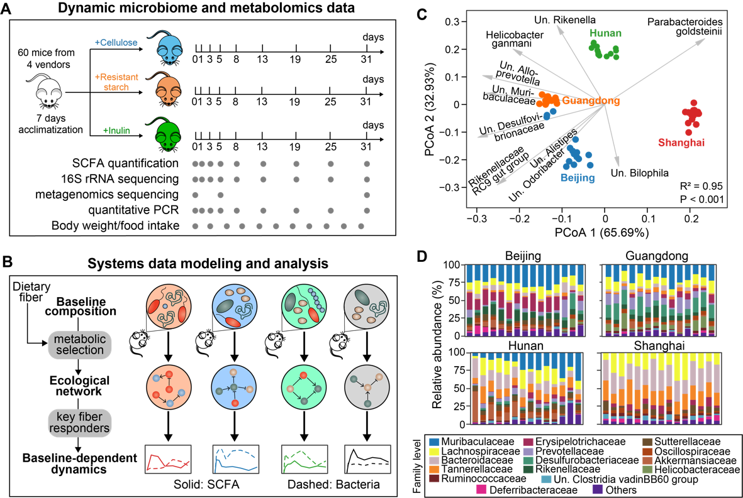

**Figure 1. Experimental design and computational framework for this study.** **A**. Schematics of the experiments performed on a mouse model. Gray dots indicate the days on which longitudinal fecal samples, microbiome and metabolomics data were collected. SCFA: short-chain fatty acid. **B**. An ecology-centric view of baseline-dependent dynamical fiber responses. We used mathematical modeling to infer ecological network under diet selection and key fiber responders that determine baseline dependency of both microbiome and SCFA dynamics. **C**. PCoA (principal coordinate analysis) plot of beta diversity of baseline microbiota composition of isogenic mice purchased from four different vendors (Beijing, Guangdong, Hunan and Shanghai). Dots represent baseline samples and gray arrows represent dominant bacterial species in the samples. The sample whose dot projects furthest in the direction of a species has the highest relative abundance of that species. R2 and P-value were obtained from Adonis analysis, which tests for baseline differences across the four vendors. T**D**.The bat family level. Bars in each subplot represent different mice purchased from the same vendor.

**Biphasic dynamics of SCFAs and gut biodiveristy**. Dietary intake of inulin and resistant starch increases mice body weight gradually over time but the amount of body weight gain is generally insignificant compared to mice treated with the cellulose control (Fig. S1A). Although there were no obvious temporal patterns in the fiber intake rate (Fig. S1B,C) and fecal weight (Fig. S1D), the fecal weight was dramatically lower in inulin- and resistant starch-fed mice, suggesting increased colonic transit time and decreased defecation frequency. Accordingly, the intestinal absorption of both fermentable fibers by gut microbiota promoted fecal SCFA concentration (Fig. 2A, S2A). Consistent with previous human studies, inulin stimulated higher production of total and three major individual SCFAs (acetate, propionate, and butyrate) than resistant starch regardless of baseline microbiota (Fig. S2B). Still, the quantitative differences in the stimulating effects of inulin and resistant starch are SCFA- and baseline-dependent.

The inulin-induced changes in fecal SCFA concentration follow biphasic dynamics: their levels peaked in short-term before gradually decreasing until steady states. Depending on the baselilne microbiota, the mean end-point level of total SCFA at day 31 is 60%-65% of its peak but 2.0-3.5 times as high as its baseline level at day 0. The long-term decrease in fecal SCFA concentration was not a result of reduced diet intake as the intake rate remains largely unchanged over time (Fig. S1B,C). Since fecal SCFAs are metabolites produced by colonic bacterial fermentation of dietary fibers, we observed similar biphasic, but undershoot, dynamics in the gut biodiversity, which drops initially before gradual increase (Fig. 2B). Concordantly, we observed rapid but non-monotonic complex changes in the relative abundance of several dominant bacterial taxa such as Bacteroides and unclassified Muribaculaceae (Fig. 2C). Similar to SCFA dynamics, the trends of biodiversity are qualitatively consistant but quantitatively different across the four baseline microbiota types. We further showed that the undershoot dynamics of biodiversity primarily resulted from changes in evenness (Fig. S3A), not richness (Fig. S3B), suggesting that the decreased biodiversity was likely caused by an expansion of resident bacteria, rather than invaders. Supporting these findings, metagenomic sequencing revealed that the initial (day 0), short (day 5)- and long (day 31)-term microbiomes have distinct gene family profiles and functions (Fig. 2D). Our dynamics data confirms previous studies on the role of dietary fibers to quickly alter gut microbiota diversity and composition on the timescale of a day indepedent of the baseline microbiota.

On contrary to inulin, no consistent termporal patterns of SCFAs and gut microbiota biodiversity were found in the resistant starch intervention (Fig. 2A,B). The alterations in gut miocrobiota composition were also milder, despite the effects are more dramatic than cellulose (Fig. S2C).

**Stablization of gut microbiota composition under sustained stimulation.** Other than the phase-dependency of inulin-mediated responses, we also found strong tendency of gut microbiota composition to stabilize under sustained stimulation of inulin (Fig. 2F) and, to lesser degree, resistant starch (Fig. S4A). Regardless of the baseline microbiota type, the steady-state compositions are distinct from their baselines for both fibers and thus represent new equilibria sustained by dietary fiber intake. Specificially, the gut microbiota in Gunagdong mice was highly resilient to inulin intervention and almost returned to its baseline composition at day 31. In addition, inulin, as well as resistant starch and even cellulose, reduced baseline microbiota differences by ~35% at day 31 (Fig. S4B), suggesting that long-term dietary fiber intervention promotes adaptative convergence of baseline microbiota towards similar composition. The adaptation is also evident in the dynamics of the dominant bacterial taxa. For example, the relative abundance of the unclassified Muribaculaceae in the Shanghai mice was initially much lower at day 0 but finally reached similar levels as in the mice from the other three vendors at day 31.

To quantify the rate of stabilization, we fit the harmonic oscillator model from physics to time series of biodiversity and calculated damping ratio—a dimensioness measure of whether and how dynamical systems approach new steady states upon perturbations—from the best-fit parameters (see Methods, Table S1). The model fits the data reasonally well with mean R2 of 73% and 61% for inulin and resistant starch respectively. The damping ratios are all equal or greater than 1, meaning that their responses were critically or overdamped and no oscillations were involved in the adaptive responses. The oscillation-free property is critical for ecosystems to maintain dynamic stability and integrity during adaptation. Although the damping ratio varies among individual mice and treatment, the dynamical responses of 42% of our mice were critical damping which leads to the fastest non-oscillatory convergence towards stationary equilibria. Interestingly, the critical damping behavior was also found in human gut microboime recovery after transient antibiotic exposure.

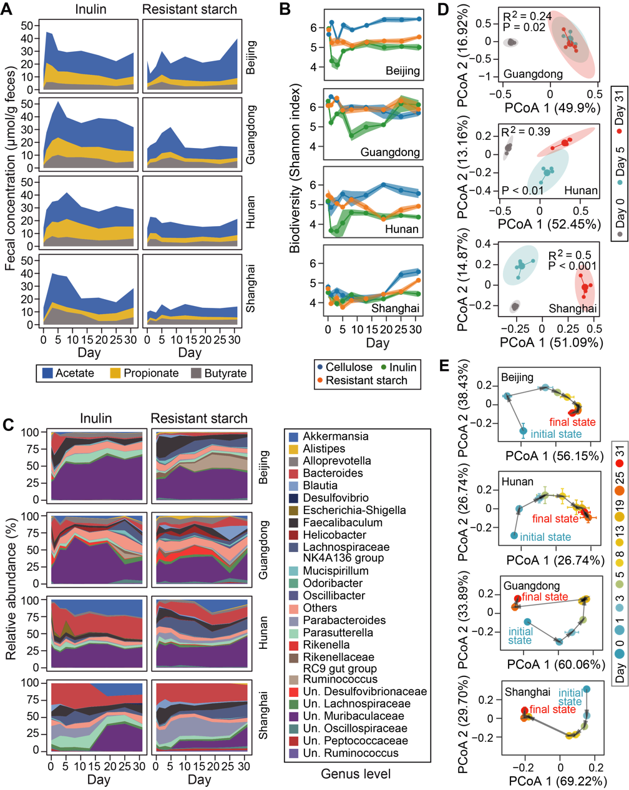

**Figure 2.** **Dynamical responses of short-chain fatty acids (SCFAs) metabolism and murine gut microbiome to dietary fiber intervention. A.** Fecal concentration of three major SCFAs. **B**. Alpha diversity of gut microbiota. **C**. Genus-level composition of gut microbiota. T**D**. Clustering of gene family profiles between day 0 (baseline), 5 (short-term) and 31 (long-term) following inulin intervention shown by PCoA (principal coordinate analysis) plots. R2 and P-value were obtained from Adonis analysis. For each cluster, smaller dots represent individual mice. The bigger dot represents the cluster center and an eclipse was drawn around the average to show the 95% confidence interval. **E.** Trajectories of gut microbiota composition responses to inulin in PCoA coordinates. The heights of stacked bands (panels A, C), lines (panel B) and dots (panel E) represent the mean values across mice within the same vendor. Shading areas (panel B) and error bars (panel E) represent standard error of the mean.

**Inferring dietary fiber responders.** A number of culturable bacteria could metabolize inulin and resistant starch *in vitro* but an *in vivo* understanding of the bacterial fiber degraders and the ecology correlated with their fermentation has not been established yet. Since genomic approaches rely on strain-level identifiability and culturability, we switched to a data-driven approach that aims to identify responders that can directly or indirectly metabolize dietary fibers. If such responders exist, we would expect increased abundance of their populations with a concomitant higher level of enzymes capable of fiber degradation following treatment. Indeed, the relative abundance of genes encoding inulinase significantly increased from day 0 to day 5 and/or day 31 (Fig. 3A), suggesting that inulinase may be a metabolic trait that has been selected for by inulin.

To infer dietary fiber responders from the complex microbiota, we employed the generalized Lotka–Volterra (gLV) equation to model the observed dynamical responses. The gLV model phenonmenlogically summarizes the underlying ecology by three terms that additively determine bacterial growth rates (Fig. 3B): the basal growth rates (), the influences from other bacteria (), and the impacts of environement (). In this study, represents the growth responses of bacteria to dietary fiber. To estimate the uncertainties associated with these parameters, we further formulated the inference problem in a Bayesian framework (see Methods) and responders are defined as those bacteria whose 95% credible interval of the posterior distribution of is completely to the right of 0. Since gLV is a differential-equation model, it is naturally more ameanable to analyzing longitudinal data compared to cross-sectional statistical tests making pre-post comparisons. Indeed, the bacteria whose relative abundances were significantly altered by inulin vary depending on the day of sample collection (Fig. S5).

Since gLV models the absolute abundance of bacterial taxa, we measured the fecal bacterial density of each sample by quantitative PCR (Fig. 3C) and then multiplied the density by their relative abundance to calculate absolute abundance. Except for the Shanghai group (despite high inulinase abundance), inulin nourished gut microbes by rapidly (in a day) boosting their density to more than 70% of maximum load. Considering ecological forces driving microbiome dynamics are largely host-independent, the time-series data from all mice were simultaneously fed into the gLV model. We identified five positive inulin responders at different taxonomic levels (Fig. 3D): Bacteroides acidifaciens (speices), unclassified Muribaculaceae (family), unclassified Faecalibaculum (genus), unclassified Parasutterella (genus), and unclassified Bacteroides (genus). Since gLV incorporates bacterial interactions (e.g., cross-feeding) as confounding variables, these responders are mostly likely to be primary inulin degraders. In fact, genetic and/or *in vitro* evidences have been found to support the role of some of them in degrading inulin (Table S2). For example, members from Bacteroides and Muribaculaceae harbor gene clusters known as polysaccharide utilization loci (PULs), which contain *C/sus*homologous gene pair that facilitates sensing and import ofinulinPutative ithe metagenome-assembledFig. S6. Other than competitions, we also found an positive influence from Bacteroides acidifaciens. Since Akkermancia muciniphila cannot degrade inulin, the indirect effects explains why it is not inferred as a responder given its relative abundance is significantly altered (Fig. S5).

For resistant starch, three bacterial taxa—unclassified Faecalibaculum (genus), muribaculaceae (genus), and unclassified Desulfovibrionaceae (genus)—were inferred as responders and all have been implicated in utilizing resistant starch from literature (Table S2). [Discuss of literature]

**Additional dataset confirms our major findings**. To corroborate our findings on the inulin-induced dynamical responses and inulin responder, we reanalyzed the raw data from a recent longitudinal study with similar experimantal setup, which also profiled the gut microbiota compositions of mice based on 16S rRNA sequencing after inulin intervention. Their data independently showed undershoot dynamics of biodiversity and its tendency to converge after 14 days (Fig. S7). By applying our inference approach to the relative abundance of their gut microbiota data, the only responder was Bacteorides acidifaciens. The agreement in these findings underscores the notion that the characteristic responses of murine gut microbiota to inulin intervention are robustly shared among the majority of baseline microbiota compositions.

**Inulin responders as a functional guild shape microbiota dynamics.** Compared to taxonomic groups, ecological guilds (groups of bacteria that perform similar ecological functions) are more fundemantal units for microbiome data analysis. In line with the guild-based concept, the inferred responders, though taxonomically heterogenous, define a core group that participates in dietary fiber degradation. By coarse-graining and partitioning microbiota dynamics between responders and other bacteria (mainly Akkermansia municipila and Bacteroides unifomics), we showed that the total relative (Fig. S8A) and absolute (Fig. 3E) abundances of the inulin responders dominate the responses of the entire microbiota in short-term (Guangdong, Hunan), long-term (Shanghai), or even the entire period of observation (Beijing). Specificially, the total density of other bacteria in Hunan mice has a delayed response and the dynamics of the two guilds co-oscillated after the delay. It is likely the delayed succession of bacterial blooms [12] may result from niche opening and occupation by cross-feeders that utilize simple sugars realeased from the inferred responders.

Substantial heterogeneity was observed among the dynamical responses of the five inulin responders (Fig. 3E, S8B, S8C). Bacteroides acidifaciens and unclassified Facelibaculum showed transient dynamics with quick rise and drop in their relative or absolute abundances, which correspond to and may explain the undershoot dynamics of biodiversity (Fig. 2B). By constrast, the relative or absolute abundances of unclassified Muribaculaceae increased continuously and remained high level through the entire period of observation. Except for Shanghai mice, the total bacterial density reached local maximum rapidly within 1-3 days (Fig. 3C), suggesting that these responders may compete for inulin after the gut microbiota has reached its maximum load in the initial response. The internal competition was supported by the gLV-based inference of bacterial interactions (Fig. 3F), where unclassified Muribaculaceae negatively influenced the growth of Bacteroides acidifaciens and unclassified Facaelibaculum (highlighted in red). This activation-then-competition mechanism found *in vivo* has been observed in a synthetic community of two auxotrophic yeast strains under high amino acid supplementation.

Compared to inulin, the guild of resistant starch responders plays much less dominant role in shaping the overall response of gut microbiota (Fig. S9A). In Hunan and Shanghai mice, the total density of other bacteria, despite not inferred as responders, increased sharply to higher levels than that of the responders. One possibility of this seemingly counterintuitive result might be an uneven distribution of a large number of resistant starch-degrading bacteria in the baseline communites across vendors, such that the responders showing mild effect in specific vendors did not pass the significance tests of a 95% credible interval. Nonetheless, we found similar trends as in inulin-group mice for the dynamics of unclassified Muribaculaceae and unclassified Faecalibaculum (Fig. S9B): the absolute abundance of the former bacteria showed gradual but continued increase, while that of the latter bacteria showed a quick rise-and-drop pattern. GLV-based inference further suggests that the observed dynamcis may be driven by mutual inhibition between the two taxa (Fig. S9C).

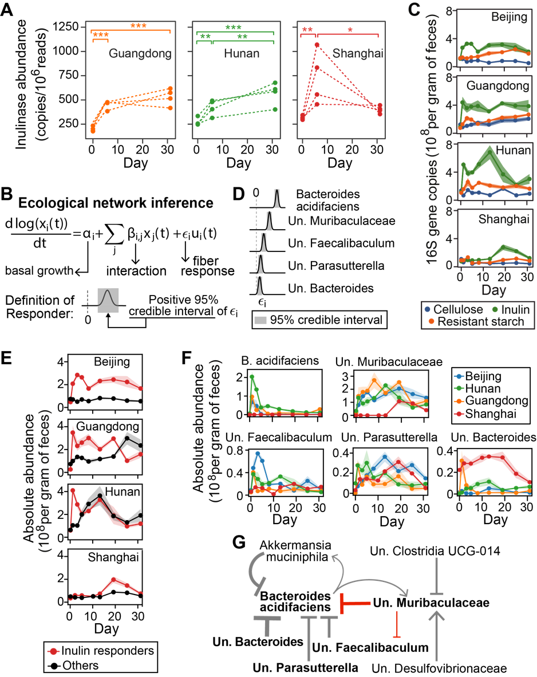

**Figure 3. Inulin** **responders** **and associated ecological interactions. A.** Increased expression of inulinase genes following inulin treatment. Each dotted line represents an individual mouse. *: P < 0.05; **: P < 0.01; ***: P < 0.001. **B**. Generalized Lotka-Volterra model combined with Bayesian statistics to infer inulin responders and species interactions. **C**. Total bacterial density measured by quantitative PCR. **D.** Posterior distribution of five bacterial species with significant growth responses (inulin responders). **E**,**F**. The total (E) and individual (F) absolute abundance of five inulin responders shown in panel D. The five responders show heterogeneous responses but together determine the short-term dynamics of gut microbiota. **G.** Core ecological interaction network constituted by significant interspecific interactions (self-interactions not shown). Inulin responders (bold font) and key inhibitions (red arrows) are highlighted. Point and blunt arrows represent positive and negative interactions respectively. The arrow thickness is proportional to the posterior mean of the corresponding interaction coefficient. Significance was determined when 95% credible intervals of the interaction coefficeints ( in panel B) do not include 0. For panels D, F, G, taxonomic labels w/ “Un.” group bacteria that are unclassified or uncultured at lower taxonomic ranks**.**

**Dynamical responses of gut microbiota and SCFAs are baseline-dependent.** We have shown above that the Shanghai mice were initially inert to inulin stimulation (Fig. 3C). The lack of short-term response can be explained by the extremely low relative abundance of two major inulin responders—Bacteroides acidifaciens and unclassified Muribaculaceae, both of which were two orders of magnitude lower in their baseline microbiota compared to mice from other vendors (Fig. S8B). Although this clearly shows baseline-dependent responses of gut microbiota to dietary fiber intervention, it is unknown how broad the baseline-dependency is among the responses of gut bacterial species. To quantify the baseline effects, we first transformed each time series from both intervention and control group into a 2-dimensional space (Fig. S10) and then compared the coarse-grained representation among different vendors after adjusting the responses from the comparator arm (see Methods). Compared to previous approaches that measure intervention effects by inspection of cross-sectional changes in the intervention group alone, the control group data was purposely introduced to avoid the caveat that the pre-to-post changes may be entirely attributed to random variations within each indivudal. For each species, we obtain two P-values that test for the significance of responsiveness (Pr) and baseline-dependency (Pb), corresponding to the differential responses between the intervention and control group and between the different baseline microbiota types respectively.

Using the framework, we identified 20% and 11% species, for the inulin (Fig. 4A) and resistant starch (Fig. S11A) intervention respectivley, that exihibit significant baseline-dependent responses (both Pr and Pb < 0.05). By constrast, the calculations based on pre-to-post changes vastly overestimated the percentages (~50% for both fibers), further reinforcing the necessity of taking control group into accounts for analyzing interindividual differences. As a byproduct, our approach also facilitates visualization of baseline-dependency for any bacterial species: the averaged response difference of the species between intervention and control group is represented by an arrow and colored based on the baseline microbiota the intervention was administered to. The data visualization technique preserves the key information regarding response differences between baseline microbiota types. For example, an enrichment of Akkermansia muciniphila—a mucin-degrading bacteria whose abundance often increases after prebiotic treatment [21]—was observed in Hunan and Shanghai mice (from day 5 and day 19 respectively), but not in Beijing and Guangdong mice, following inulin intervention. This baseline effect was also reflected in the simplified graph: the green arrow (Hunan) is longest and points to northeast direction; the red arrow (Shanghai) is the second longest and closely aligns with the y axis; the orange (Guangdong) and blue (Beijing) arrows are much shorter and negligible.

Baseline effects were also observed in the dynamics of SCFAs. Fig. 2A shows that Guangdong mice exihibit the most pronounced responses of individual SCFAs to inulin treatment while the propionate production in Shanghai mice were significantly delayed and compromised. For inulin intervention, the baseline-dependency of butyrate and propionate, but not acetate, was tested to be significant (Fig. 4B). For resistant starch intervention, the dynamical responses of all three SCFAs were found significantly dependent on baseline microbiota composition (Fig. S11B). Interestingly, the dynamics of total SCFAs are baseline independent for both fibers, suggesting that baseline microbiota may only regulates the proportions of different SCFAs but not the total concentration. It worths mentioning that the above analysis of baseline effects incorporated information from the whole time series, which may or may not agree with statistical tests performed at single timepoints (Fig. S12). These cross-sectional tests are even inconsistent within themselves; for example, the butyrate and propionate concentrations are baseline-dependent on day 5 but independent on day 31 following inulin interventions (Fig. S12A).

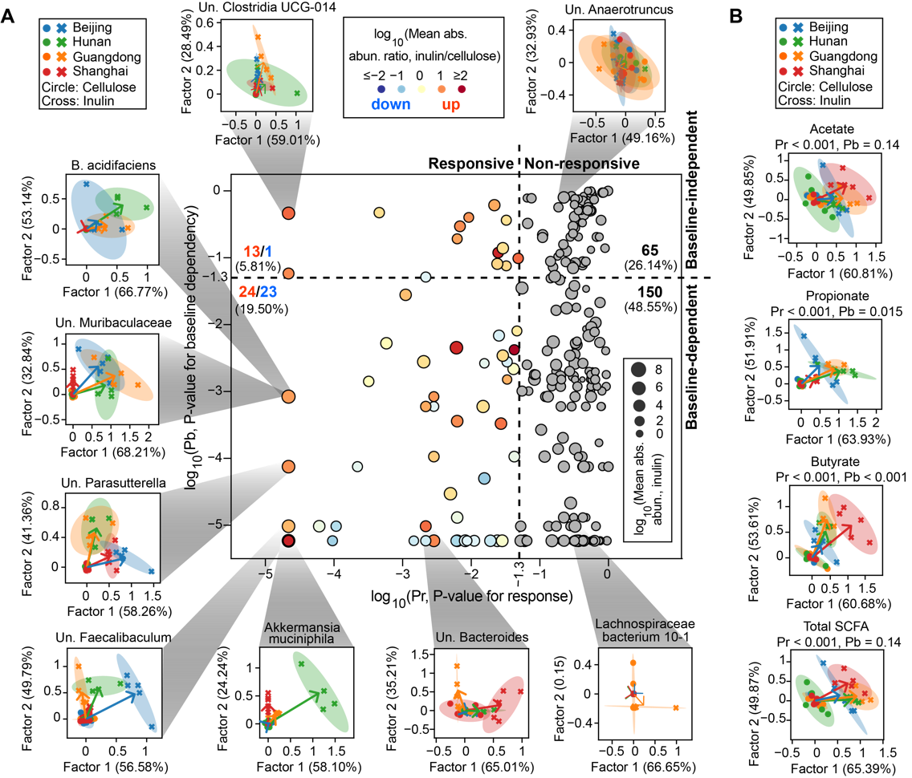

**Figure 4. Quantification and visualization of baseline-dependent responses of (A) bacterial species and (B) short-chain fatty acids (SCFAs) to inulin intervention.** The scatter plot in the center of panel A distinguishes four different scenarios of baseline-dependent responses depending on the P-values for significance test of responsiveness (Pr) and baseline-dependency (Pb). The non-responsive bacterial species are marked as gray dots, while the responsive ones are colored by the ratio of their averaged absolute abundances (abs. abun.) between inulin and cellulose group. We displayed the inulin-stimulated longitudinal responses of bacterial species and SCFAs, relative to their corresponding responses in the cellulose group, in a reduced two-dimensional (2D) space spanned by factor 1 and factor 2 extracted using sequential non-negative matrix factorization (see Methods for details). In the 2D visualizations, each symbol represents a mouse (dots: cellulose group, crosses: inulin group) and all mice data from the same vendor under the same dietary fiber treatment was used to fit an eclipse. For each vendor, an arrow was drawn from the eclipse center of the vendor under cellulose treatment (standardized to the origin) to that under the inulin treatment. Numbers in parentheses on x- and y-axis labels indicate factor loadings. Taxonomic labels w/ “Un.” group bacteria that are unclassified or uncultured at lower taxonomic ranks.

**Baseline-dependency impedes prediction of SCFAs from microbiota composition.** Prediciting metabolomes from microbiota has been of long-standing interest but there has been controvercies regarding whether metabolome, especially SCFAs, is predictable. We evaluated the performance of machine learning models to predict the SCFA concentrations using absolute abundance of bacterial taxa as predictors. All mice were split into training and test sets using two data-split approaches (Fig. 5A). The “intrapolation” strategy generated balanced distribution of baseline microbiota between the training and test sets by randomly sampling a single mouse from each vendor into test and leaving the other mice of the same vendor for training. By contrast, the “extrapolation” strategy produced highly unbalanced microbiota distribution by randomly picking mice from a vendor for test and leaving mice from the other vendors for training. Using a Random Forest regression model, the training accuracy in terms of R2 is at least 66% regardless of SCFAs and data-split stratiegy. In the scenario of “intrapolation”, the prediction accuracy of the three SCFAs varies from 10% to 45%, where butyrate is the most predictable SCFA probably due to its conserved pathways for de novo biosynthesis. However, though not surprisingly, the prediction accuracy is less than 0 for all SCFAs in the “extrapolation” scenario, meaning that our model is highly overfit and generalizes worse than any linear model. We further showed that the poor performance of predicting extrapolated dataset cannot be significantly improved by using alternative models (Fig. S13A) or predictors (Fig. S13B). In both scenarios, the Random Forest predictions are even more inaccurate using data obtained during resistant starch intervention (Fig. S13A).

We hypothesized that the poor performance of Random Forest model stemmed from dependence of SCFAs concentrations on basline gut microbiota. By counting the presence and absence of each species in the baseline samples (Fig. 5C, S13B), we found that the 85% bacteria was only present in a subset of mice and >70% was not present in all vendors regardless of the intevention. Some of these bacteria that are missing in at least one vendor have been inferred as SCFAs producers (Fig. S14A). Quantitatively, we used Random Forest classifier to test the similarity of gut microbiota between the training and test datasets in the “intropolation” and “extrapolation” scenarios. For both fibers, we found that testing set can be almost completely predictable from the training set when the entire data was split following the “extrapolation” strategy, while the two sets are largely indistinguiable following the “intrapolation” strategy (Fig. 5D, S13C). The problem of the changed distribution between training and test dataset is formally known as covariate shift, which can be sometimes counteracted by assigning weights to training sets to reduce the distribution gap. Unfortunately, the baseline gut microbiota between vendors seem to be too different and adding weights does not improve the prediction accuracy (Fig. S12C).



**Figure 5.** **Prediction of short-chain fatty acids concentrations from gut microbiota using machine learning models. A**. Two data-split strategies for testing model performance. Mice in the test sets were randomly selected on a one-per-vendor basis for “interpolation” and exclusively selected from a single vendor for “extrapolation”. Data before intervention (i.e., day 0) was not included. **B**.Performances of Random Forest regression models on the training and test datasets. **C**. Presence (threshold: 0.001%) and prevalence of bacterial species in baseline microbiota across mice and vendors. In the bottom panel, the prevalence score of a species across mice (solid line) was defined as the fraction of mice that contains this species in their baseline microbiota and that across vendors (dashed line) was the fraction of vendors whose mice all contain this species. **D**. Receiver operating characteristic (ROC) curve analysis of the similarity between training and test datasets. A Random Forest classifier trained to discriminate the two datasets outputs area under the ROC curve (auc) as a dissimilarity metric.

**Discussions/Conclusions**

# Summary of the major findings of this study and focus on why dynamics is important for understanding individualized responses

In summary, our results indicated paramount importance of dynamics for understanding inter-individual differences in dietary responses. The significance of dyanmics is two folds. First, inter-individual variability is a function of time and dynamic data provide temporal trends allowing for better quantification of individualized responses. Compared to pre-post changes, temporal trends improve our ability to distinguish responses that have different shapes but the same end-point values. For example, opposite conclusions regarding the significance of inter-vendor differences would be drawn for the inulin-induced butyrate and propionate responses using an end-point of 5 day or 31 day. Second, dynamics bridge the gap between baseline state and end-point state to reveal how input variability evolves and transforms into readout variability. For instance, the inter-vendor variability of total biomass at day 31 following inulin intervention is mainly due to lower bacterial density in Shanghai mice, which can be further linked to the low relative abundance of two inulin responders—Bacteroides acidifaciens and unclassified Muribaculaceae—in their baseline microbiota. Without time series data, it would be difficult to precisely pinpoint the sources of heterogeneity as the inference of inulin responders based on pre-post changes would possibly result in both false-positives (e.g., bacterial density increases just before study end-point due to indirect effects) and false-negatives (e.g., bacterial density increases initially but drops to baseline levels before study end-point). Taken together, characterizing dynamic responses to dietary fiber intervention across individuals, with integrated longitudinal analysis of 16S rRNA sequencing, metagenomics and metabolomics, is an important priority for microbiome research to further understanding of diet-induced responses. Such studies thus have the potential to provide predictive insights into how dietary fiber can be harnessed to improve human health or treat disease via gut microbiome engineering.

# Discuss the relevance of our studies to the literature

Diet-induced changes in SCFAs are often transient and vanish shortly after cessation of dietary intervention [25-28]. Our experiments add to the literature by further showing that SCFA concentrations cannot be maintained at its peak and drop by 35%-40% even under continuous inulin intake until 4 weeks [29]. The transiet responses under sustained dietary fiber intake was also observed in colorectal cancer patients [30]. Despite the drop, our data demonstrates that a continuous intervention that lasts for 31 days is sufficient to elevate and stabilize the SCFAs concentration, but it is not clear yet whether the elevated level persists after the intervention discontinues. We envision two possibilities that may explain the after-peak decrease of SCFA concentration. First, some bacteria are known to consume SCFAs and a net consumption of SCFAs may occur when SCFAs consumers dominate over producers. The other possibility is increased absorption of SCFAs by host cells, leaving less produced SCFAs excreted to feces. In healthy individuals, the percetange of bacteria-derived SCFAs that appear in feces is 5%. Considering the majority of SCFAs are consumed by the host, it is important to note that fecal SCFA concentration may not reflect their concentration in the intestine.

# How our inference approach helps curb the replicability issue

Using public datasets, we demonstrate that our approach for inferring dietary fiber responders helps tackle replicability issue in microbiome science. The structure of gLV allows for modeling bacterial interactions as covariants and accounting for confounding variables reduces the risk of producing biased estimates of indirect effects. Controlling for confounding variables is highly important for replicability between results from similar microbiome studies, as the underlying mechanisms driving microbiota dynamics is to a great extent shared and should play consistent roles. In fact, any scientific field that heavily relies on complex statistical anlaysis of large datasets may encounter chanllenges in replicability. Remarkably, our inference approach applied to different mouse or human gut microbiome data produced highly compatible results regarding inulin responders. In the mouse gut, both our data and data from Chijiiwa et al. agree that the strongest inulin responder is Bacteroides acidifaciens, which was also reported by a third study that treated mice with inulin (data not reanalzyed). On the other hand, reanalysis of five human datasets that all administered inulin revealed that Bifidobacterium (in four studies) and Anaerostipes (in five studies) exihibit significant responses to inulin, despite the huge differences in the pretreatment microbiota composition among human subjects in these studies (Fig. SX).

# Can we predict microbiota responses from baseline abundance of responders?

By combining gLV model and Bayesian regression, we identified multiple inulin and resistant starch responders from the complex microbial community of the murine intestine, which we believe play critical roles in bridging the variability in baseline microbiota to the variability in microbiota responses. Then, it comes a question: Can we predict microbiota responses simply from the relative abundance of these responders in the baseline community? To answer this question, we first tested the statistical association between baseline relative abundance of each individual responder and accumulated bacterial density (area under the curve) as a proxy for microbiota response. Not all inulin responders are equally predictive and positive correlations were only found in Bacteroides acidifaciens and Muribaculace (Fig. SXA). The negative associations of the other three responders do not necessarily contradict their identity of being responders because different approaches and data are involved. By combining the two responders, their total relative abundance can explain 75% of the variability (Pearson correlation) in microbiota response. Simiarly, the total relative abundance of Muribaculaceae and Desulfovibrionaceae in the baseline community explains 86% of heterogeneity in microbiota response induced by resistant starch (Fig. SXB). Although not perfect, our study provides guidances on how to develop predictive metrics of microbiota response under dietary fiber intervention.

# Discuss the major reason for the failure of predicting SCFAs from microbiota composition

Considerable debates have been raised over the feasibility of predicting metabolite profiles solely based on microbiome sequencing data. For example, the MelonnPan algorithm based on linear regression accurately predicted relative abundances of >50% metabolites from metagenomes in patients with inflammatory bowel disease and healthy controls. Oppositely, it was also reported that only 14% of the observed variation in the SCFAs concentration can be explained by Random Forest regression models trained on 16S rRNA or metagenomic gene sequences in colorectal cancer patients and healthy controls. While the possibility of using different regression models and patient cohorts between these controveral studies cannot be exlucded, our study points out that the similarity of data distribution between training and test sets, which is strongly affected by the degree of inter-individual variability of gut microbiota, may contribute to the disagreement. Using mouse models, we showed that the predictability was completely lost when extrapolating models to predict SCFAs from gut microbiota types that were unseen during training (Fig. 5). In studies with human, inconsistent model performances may be attributed, at least partially, to the neglection of stratified train-test split and the subsequent outcomes, i.e., microbiota compitions between training and test sets are not independent and identicially distributed (i.i.d.). Even though data split is stratified based on microbiome characteristics, regression models may still perform poorly in cases when inter-individual variabilty is too large to fulfill the i.i.d. assumption, the violation of which would cause covariate shift and maching learning to fail. To improve model predictability, large-scale human cohorts are therefore needed to cover the substantial inter-individual variation of human gut microbiome.

# Complex microbiome-metabolome relationship is another challenge for predictive SCFAs

Other than covariant shifts, the complex relationship between SCFAs and gut microbiota composition poses an additional challenge for predictive model development. By regressing SCFAs concentration on absolute abundance of microbes, we implicitly assume that SCFAs concentration remains unchanged if gut microbiota has a steady composition. However, this assumtipon does not always hold and here we provided two pieces of evidences concerning its violation. First, Shanghai mice showed delayed changes in total biomass (Fig. 3C) following inulin intervention but their acetate and butyrate concentrations were neither delayed nor compromised (Fig. 2A). Second, SCFAs were highly produced by gut microbiota that maintains relatively stable composition between day 0 and day 1, regardless of vendors (Fig. SX). It is likely the mouse gut resembles an *in vitro* culturing system at the beginning of intervention when the microbiome-metabolome relationship follows a rate model, i.e., gut microbiota composition determines the change in SCFAs concentration. Taken together, the decoupling of SCFAs from overall microbiota response suggests that SCFAs responses may be additionally regulated at transcriptional (gene expression) and metabolical (enzyme activity) levels. Our evidences for potential molecular-level regualtions justify the emerging essentiality of integrating transcriptomics and metabolomics data in dietary response analysis.

# Discuss the challenge of finding SCFAs producers

The above-mentioned challenge of predicting SCFAs from gut miocrbiota composition brings similar difficulties in robust inference of SCFAs producers. Using three different approaches, we showed that the inferred top producers do not agree with eacht other. Taking propionate producers as an example. The random forest model developed in Fig. 5 ranked propionate producers based on their Gini importance scores and the top three are Bacteroides acidifaciens, unclassified Alloprevottella and Akkermansia muciniphila. The second approach is repeated correlation, which identified Parabacteroides distasonis as the sole significant producer. According to the random forest model, Parabacteroides distasonis ranked the 5th among all bacterial species. The third approach also trained a random forest model but on only subset of data. SCFAs production may follow a rate model within the first day (Fig. SX), the model was trained on the baseline and first-day data and identified unclassified Parabacteroides, xx, and xx as the top three propionate producers. Among the three candidate species, the absolute abundance of unclassified Parabacteroides showed a linear association with propioinate change between day 0 and day 1, while this association fades away in data after day 1. The finding that unclassified Parabactoierder as the top producer is promising, not only due to in vitro support of its fermentation capability, but also it explains why Shanghai mice has a low propionate level. It is important to note that the low propionate cannot be convincely explained by low biomass as its acetate and butyrate levels are at comparable levels to the other vendors.

# Limitations in translating knowledge from mice experiments to human

We note two major limitations that may hinder translating the insights provided from our mouse experiments to humans. First, mice have much less inter-individual variability than humans. Since individual mice in our study can be stratified into four distinct microbiome types based on vendors, the major conclusions we draw were essentially based comparative analysis of dietary responses among the four microbial communities each with several replicates. Whether and how well the four communtiy types correspond to the enterotypes—distinct micrbiome configurations—in humans are worth further study. To soften this limitation, we have made efforts to augment the microbiome diversity by reanalyzing public dataset from a similar study. Second, the murine gut microbiota has distinct compositions from humans [39]. Although Bacteroidetes and firmicutes are two major phyla shared between mice and human, 85% genera found in the mouse gut are not detectable in the human gut. For example, the family Muribaculaceae—a major inulin responder inferred by this study—was specific to the mouse gut. Moreover, the differences in microbitota cmpsotioin between mice and human diversify the gut environment at functional levels, resulting in differential dietary responses of the same microbes between the two ecosystems. For instance, the two human inulin responders—Bifidobacterium and Anaerostipes—were present in the mice gut but their relative abundances remain low and unresponsive to inulin intervention throughout the entire period of observation (Fig. SX). This example shows that bacteria responding to dietary fiber in one of the two mammalian systems may not consistently respond in the other, suggesting that community ecology may play an selective role in the activation of fiber degraders depending on the surrounding environment.

**Methods**

**Animal experiment.** Specific-pathogen-free (SPF) female C57BL/6J mice for different gut microbial composition were obtained at 6 weeks of age from Beijing (A Charles River Company, Beijing, China), Hunan (Hunan Slac Jingda Laboratory Animal Company, Ltd., Changsha, China), Guangdong (Guangdong Medical Laboratory Animal Center, Foshan, China)), Shanghai (SLAC Laboratory Animal Co., Ltd., Shanghai, China). Mice were maintained on a 12-h light/dark cycle and allowed ad libitum access to food and water throughout the experiment. After acclimatizing to the diet and housing environment for 1 week, mice from each vendor were randomly separated into three groups: cellulose group, resistant starch group, and inulin group (n = 5). Composition of all diets including the source of dietary fibers cellulose, resistant starch, and inulin are provided in supplementary table 1 (**Table S1**). Fecal pellets from each mouse were freshly collected over multiple time points: day 0 (before diet change), day 1, 3, 5, 8, 13, 19, 25, and 31 (Figure 1A). Fecal samples were snap-frozen in liquid nitrogen and stored at −80 °C until further processing. At every cage change (moving the mice to a new clean cage with fresh bedding twice in one week), body weight was individually measured, and food intake and fecal output of each cage mice during the past three days per cage were measured. This study was performed in accordance with the recommendations of the National Care and Use of Animals Guidelines (China) and approved by the Institutional Animal Care and Use Committee (IACUC) of the Shenzhen Institutes of Advanced Technology, Chinese Academy of Sciences.

**GC-MS analysis of fecal SCFA concentration.** The SCFAs were analyzed according to the previous studies with modifications [42]. For the sample extraction, 0.05 g of frozen feces were mixed with 300 µL of pure water containing caproic acid-6,6,6-d3 (CDN Isotopes, Quebec, Canada) as internal standard (IS, final concentration 20 µg/mL). After adding 1.0 mm diameter zirconia/silica beads (BioSpec, Bartlesville, OK), feces were homogenized for 20 s under 6500 rpm for three times, then incubated at 4 °C with shaking for 30 min, followed by centrifugation for 30 min at 13,000×g. Following extraction with anhydrous diethyl ether, the SCFA extract accurately transferred into a glass insert in a GC vial and capped tightly after added 5 µl of N, O-bis(trimethyl-silyl)-trifluoroacetamide and vortexed for 5 s. The mixture was kept in the GC vial and incubated at room temperature (22 °C) overnight (or over 8 h) before loading to GC/MS. The analysis of acetic, propionic and butyric acids was performed by Agilent 8890/7000D triple quadrupole GC/MS equipped with a capillary HP-5 ms capillary column (30 m × 0.25 mm × 0.25 µm film thickness) (Agilent Technologies). The analytes were quantified in the selected ion monitoring (SIM) mode using the target ion and confirmed by confirmative ions. The concentration was determined with reference to the peak side of IS.

**DNA extraction and quantification of bacterial load.** For extraction of DNA, fecal material from pellets was extracted using the QIAmp PowerFecal DNA kit (Qiagen, #12830–50) following standard manufacturer procedures. DNA samples were resuspended in Buffer C6 and quantitated using the Qubit fluorometer (ThermoFisher Scientific). To quantitatively assess bacterial load, total bacteria cell counts were determined using qPCR as described recently [43].

**Amplicon and metagenomic sequencing.** 16S rRNA gene sequencing was performed as previously described with modifications [44]. Library preparation was done using a two-step PCR method. During the first step of PCR, primers S-D-Bact-0341-b-S-17 and S-D-Bact-0785-a-A-21 were used to target and amplify the v3-4 region, as well as to add second-step priming sites. Dual index codes were added to each sample at the second PCR step. The PCR products were purified with Agencourt AMPure XP magnetic beads (Beckman Coulter, Brea, CA, USA) and quality controlled with TapeStation (Agilent Technologies, Santa Clara, CA, USA). The final DNA concentrations of the purified products were measured with a Qubit 2.0 fluorometer (Thermo Fisher Scientific). The purified products were pooled in equal molar concentrations, and denatured following the Illumina protocol. All sequencing was done in a single run, which was performed with a 250-cycle SP kit on the NovaSeq 6000 following the NovaSeq XP workflow (Illumina, USA). Blank controls (no sample added, processed routinely, n = 4) were included in the extraction process to control for contamination throughout processing.

Metagenomic sequencing was performed using fecal samples from the inulin diet group at day 0, 5 and 31. Extracted DNA sample was purified using silica-based columns. Metagenomics sequencing libraries were prepared with at least 2 μg of total DNA using the Nextera XT DNA sample Prep Kit (Illumina, San Diego, USA) with an equimolar pool of libraries achieved independently based on Qubit 2.0 fluorometer results combined with SYBR Green quantification (Thermo Fisher Scientific, Massachusetts, USA). The indexed libraries were sequenced with a 150-cycle S4 kit on the NovaSeq 6000 following the NovaSeq XP workflow (Illumina, USA).

**Sequence analysis**. The 16S rRNA sequencing reads were analyzed in QIIME 2-2020.2 software [45]. Demultiplexed paired-end reads were trimmed to remove primers and low-quality bases with q2-cutadapt plugin. The trimmed sequences were denoised and joined with q2-dada2 plugin. Potential reagent contaminants were identified using decontam package based on either the frequency of the ASV in the blank control or the negative correlation with DNA concentration [46]. The generated feature table was filtered to remove ASVs present in only a single sample and remaining ASVs were used to construct a rooted phylogenetic tree via q2-phylogeny. Rarefaction curve analysis of the data obtained was used to estimate the completeness of microbial communities sampling and performed using the iNEXT R package [47]. Subsequently, in order to avoid sample-to-sample bias due to variable sequencing depth (different number of reads per sample), samples were rarefied to 38,980 sequences per sample. Rarefaction analysis showed that great majority of the bacteria species diversity and richness that could be sampled was captured by our sequencing depth (Fig. S18), indicated sufficient sequencing depth for majority of the analyzed samples. Estimated alpha diversity metrics, beta diversity metrics (Aitchison distance [20]) and Principle Coordinate Analysis (PCoA) using q2-diversity. Group significance between alpha and beta diversity indexes was calculated with QIIME2 plugins using the Kruskal–Wallis test and permutational multivariate analysis of variance (PERMANOVA), respectively. To assign taxonomy to the amplicon sequence variants (ASVs), the q2-feature-classifier basing on the classify-sklearn naïve Bayes taxonomy classifier was used with the SILVA (v.138) as reference database.

For metagenome analysis, raw sequencing reads were subjected to quality filtering and barcode trimming using KneadData (v0.5.4) by employing trimmomatic settings of 4-base wide sliding window, with average quality per base >20 and minimum length 90 bp. Reads mapping to the mouse genome were also removed. Kraken2 was run against genome taxonomy database (GTDB_r89_54k) with default parameters [47]. Following classification by Kraken2, Bracken was used to re-estimate bacterial abundances at taxonomic levels from species to phylum using a read length parameter of 150. Next, the filtered sequences were assembled into contigs using metaSPAdes with default settings [49]. The gene abundance was analyzed and calculated as previously described with modifications [50]. Putative genes were then predicted on contigs longer than 200 base pairs using Prodigal under metagenome mode (-p meta) [51]. A non-redundant gene catalogue was constructed with CD-HIT using the parameters “-c 0.95 –aS 0.9” [52]. The abundance of each predicted gene was evaluated by mapping reads back with KMA algorithm and then normalized with the following equation: RPM = 1M × (mapped reads/gene length)/(sum of mapped reads/gene length) [53]. For all the predicted genes, CAZymes were annotated using hmmsearch against the dbCAN2 database V9 (e value <1 × 10−10; coverage >0.3) [54]. The domain with the highest coverage was selected for sequences overlapping multiple CAZyme domains. For all samples, short genomic assemblies (<2,000 bp) that could have biased the subsequent analysis were first excluded. Genomes were then binned using VAMB [55]. The binning results were refined based on the bin quality assessment (completeness >75, and contamination <15) of different binners from CheckM [56]. Taxonomic classification of each bin was determined by GTDB-tk [57], and subjected to prediction of polysaccharide utilization loci (PULz) using pipeline PULpy [58].

**Statistical analysis.** R packages *qiime2R*, *ANCOM*, *phyloseq*, *DESeq2*, *RandomForests*, *vegan*, *cluster*, *ggpubr*, *ggtern*, *rstatix*, and *ggplot2* were used for normalization, analyses, and visualization. For normally distributed continuous variables, the mean values were examined using an unpaired Student’s t test or One-way ANOVA with Tukey’s post hoc test. The level of significance was set at *P* < 0.05. Differential CAZY genes and bacterial CAGs between time points were identified using Wilcoxon matched-pair signed-rank tests (two-tailed) followed by FDR corrections.

**Beta diversity and PCoA analysis**. Beta diversity, which illustrates differences in taxonomic diversity between different vendors were examined using recently developed tools that are robust for investigating compositional data: DEICODE [20].

**Ecological inference of dietary fiber responses.** Bayesian regression techniques were used to parameterize the generalized Lotka-Volterra (gLV) model, as similarly used in Morjaria et al. The generalized Lotka-Volterra (gLV) model describes how absolute abundance of bacterial species change over time

|  |  |  |
| --- | --- | --- |
|  |  | Eq. (1) |

where is the number of bacterial taxa, is the absolute abundance of taxon () obtained by multiplying its relative abundance by the qPCR value, is the basal growth rate, represents the influence of taxon () on the growth of taxon , is the susceptibility coefficient that represents growth response to any given fiber, is a binary variable that indicates whether the fiber is administed at time . For each mice (), Eq. (1) can be transformed into a matrix form that incorporates all discrete time points of measurements (, )

|  |  |  |
| --- | --- | --- |
|  |  | Eq. (3) |

Eq. (3) can be solved by penalized linear regression to avoid overfitting. Using simplified notations for Eq. (3), i.e., , we solved the following ridge regression for each given Suppose our model has bacterial taxa whose absolute abundance was measured at distinct time points in mice. The gLV model shown in Fig. 3C was first transformed into a matrix form : is a -by- vector of log-derivatives of estimated from a cubic spline interpolation, is a -by- block diagonal matrix with each block filled with s and , and is a m)-by- vector of gLV parameters ( basal growth rates, pairwise interactions, fiber response coefficients).

where the derivatives on the left-hand side were. The matrix form was rewritten then fed into Stan program to solve the posterior distribution of these coefficients.

https://iai.asm.org/content/87/9/e00206-19

**Statistical tests of base-dependent responses.** Sequential non-negative matrix factorization was applied to transform all high-dimensional time series data from both intervention (inulin and resistant starch) and control group into two-dimensional space. We chose two-dimensioanl representation for practical purposes: (1) reconstructed time series from two principle components preserve the quantitative trends of the untransformed time series and (2) two-dimensional data can be easily visualized. To test the significance of response, we used Permutational Multivariate Analaysis of Variance (PERMANOVA) and compared the adjusted area under the curve between the intervention and control group. To test the significance of baseline-dependency, we used PERMANOVA between the four vendors. Minkowski distance was used for dissimilarity metric. Multitest correction was used to adjust P-values when all

**Random forest models.** Four hyperparameters were turned to optimize the model performance. he coarse-graining step is necessary as it extracts the main trends of time series data by filtering out random variations (noise).

**Supplementary figures:**

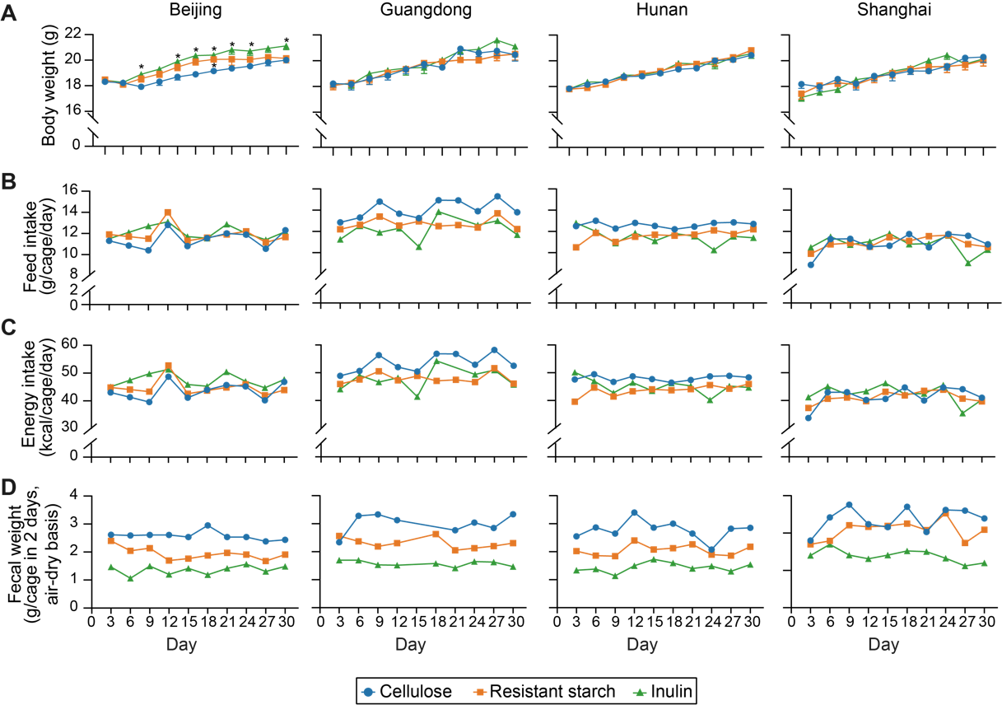

**Figure S1. (Related to Fig. 2) Effects of inulin or resistant starch on (A) body weight, (B) daily food intake, (C) daily energy intake, and (D) 48-hr fecal sample weight of mice receiving diet supplementation used in this study.** Each symbol represents the mean body weight in panel A or a single data point in panels B-D. The body weight data were analyzed by ordinary one-way ANOVA with Turkey post hoc test between inulin or resistant starch and cellulose group. *, P < 0.05.

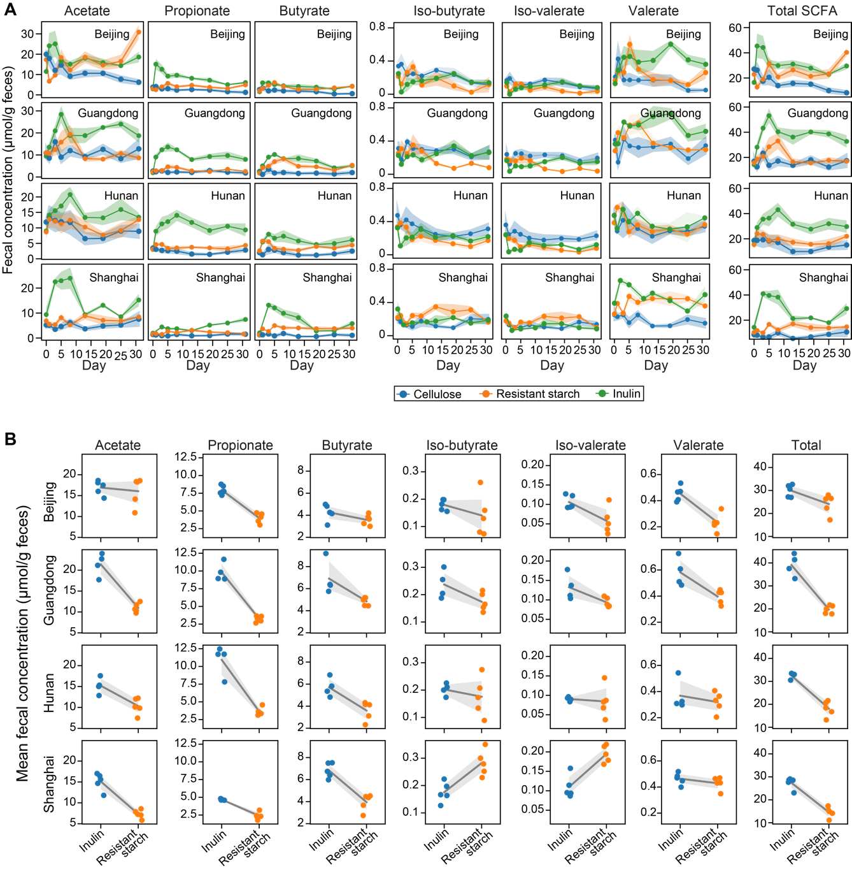

**Figure S2. (Related to Fig. 2) Dynamics (A) and time averages (B) of fecal short-chain fatty acid (SCFA) concentration following dietary fiber intervention.** Lines represent mean concentrations across mice and shading areas represent standard error of the mean.

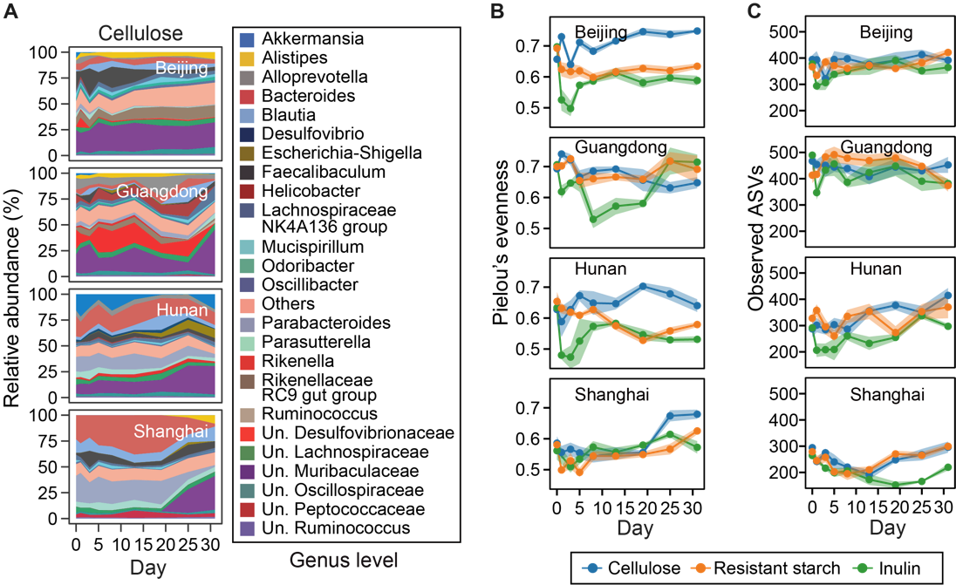

**Figure S3. (Related to Fig. 2) Dynamics of cellulose-group microbiota composition (A), evenness (B), and number of observed ASVs (C) following dietary fiber intervention.** For panel A, taxonomic labels w/ “Un.” group bacteria that are unclassified or uncultured at lower taxonomic ranks. For all panels, the heights of stacked bands (panel A) or lines (panels B, C) represent mean values across mice within the same vendor and shading areas (panels B, C) represent standard error of the mean.

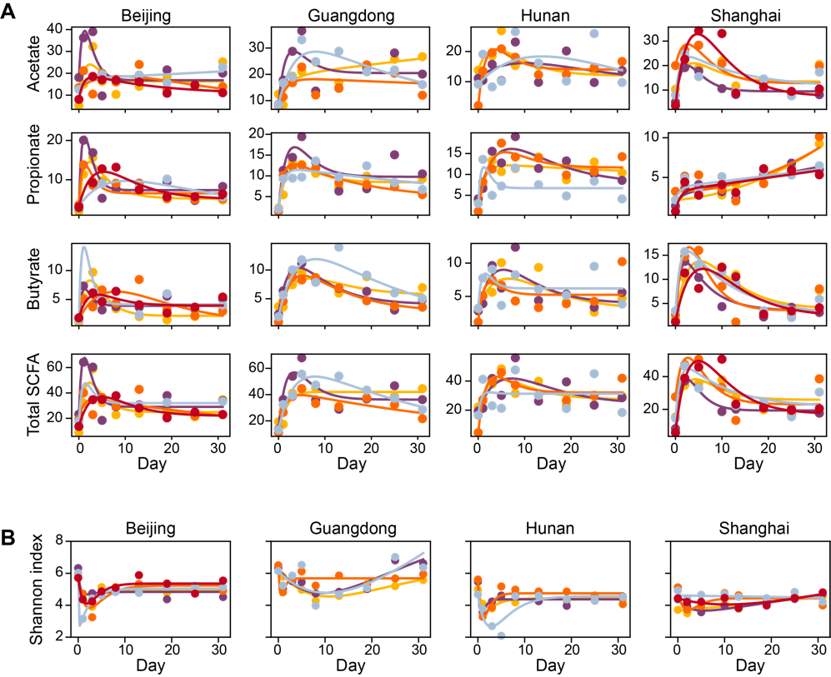

**Figure S4. (Related to Fig. 2) Fitting a harmonic oscillator model to the dynamics of short-chain fatty acids (A) and Shannon diversity (B).** Dots represent data and lines represent simulations using the best-fit parameter values. Both lines and dots are color-coded on a per-mouse basis.

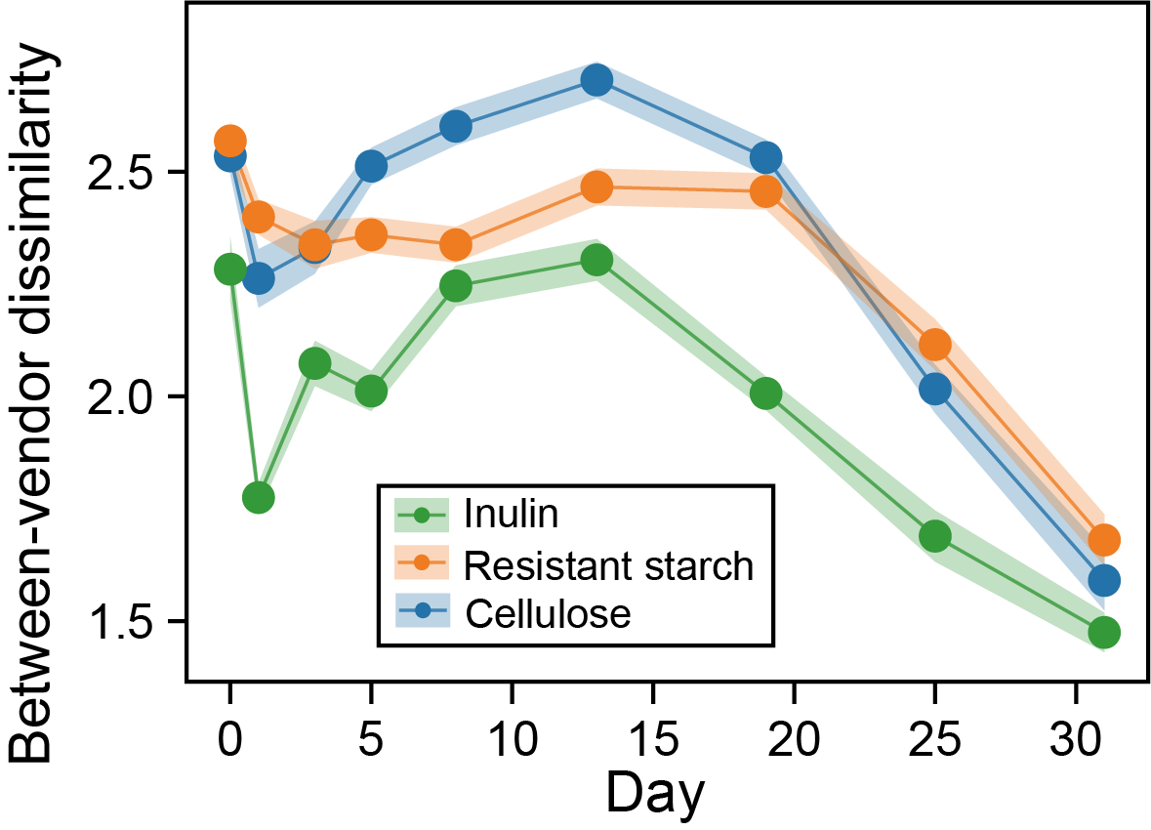

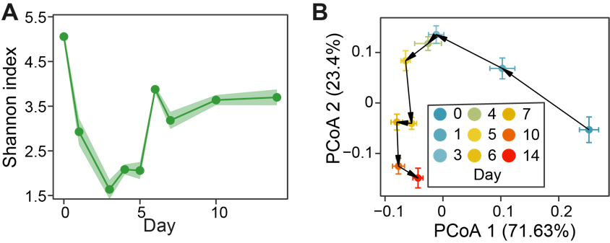

**Figure S5. (Related to Fig. 2) Reanalysis of data from Chijiwa et al., 2020, where** **a similar experiment was performed to observe the gut microbiota dynamics following inulin treatment in a mouse model.** **A**. Alpha diversity. **B**. The averaged response trajectory of gut microbiota in PCoA (principal coordinate analysis) ordination scatter plot. Each dot represents the mean principal coordinate score of all mice and the corresponding error bar represents the standard error of the mean.

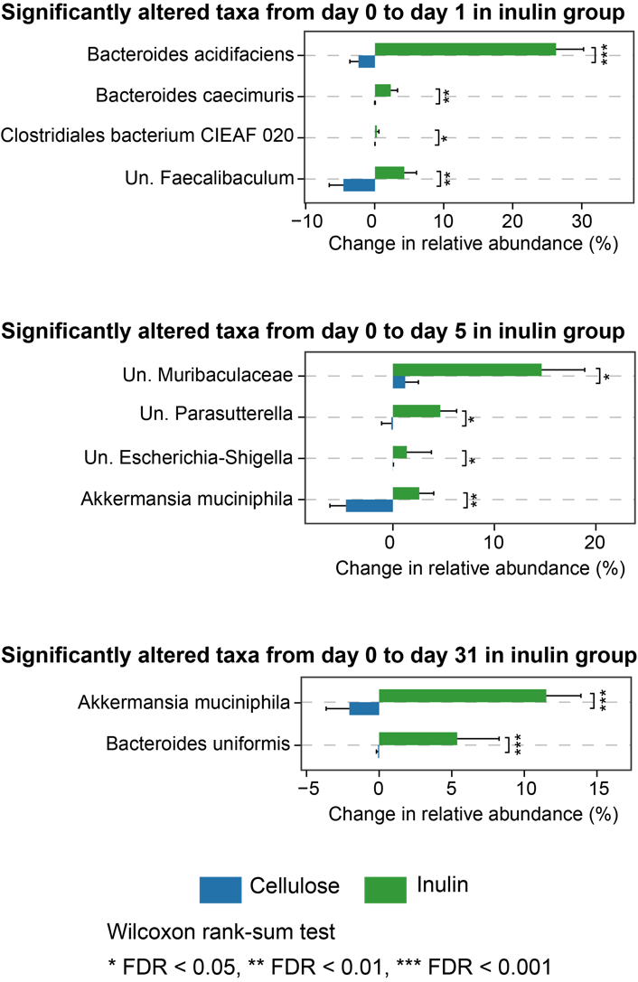

**Figure S6.** **(Related to Fig. 3) Significantly altered bacterial species in relative abundance between inulin and cellulose groups.** The identified species vary depending on the day of observation.

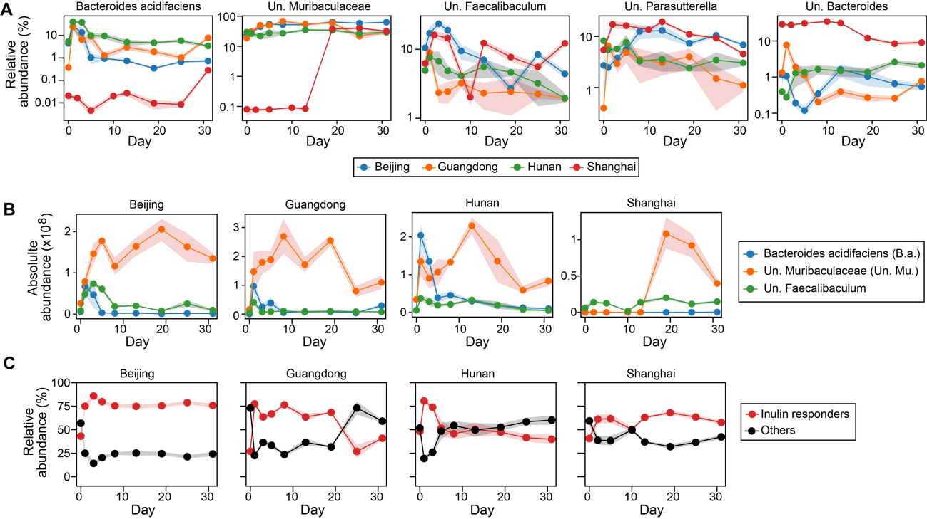

**Figure S7. (Related to Fig. 3) Dynamics of inulin responders.** **A**. Relative abundance of each inulin responder inferred from ecological network model. **B**. Three responders that might compete for inulin (see the main text Fig. 3F for inferred interspecific interactions). **C**. Comparison of total relative abundance between inulin responders and other bacterial species.

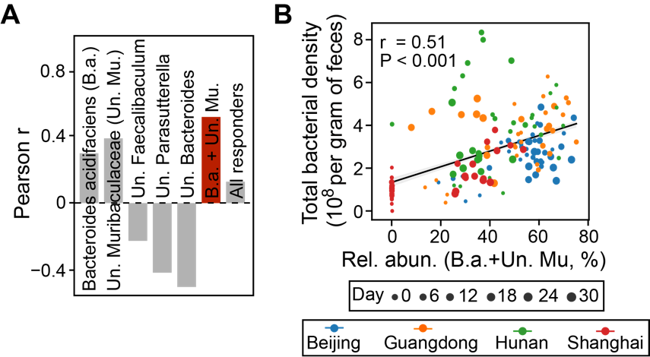

**Figure S8. (Related to Fig. 3) Prediction of total bacterial density (i.e., absolute abundance) from relative abundance of inulin responders.** **A**. Pearson correlation for different combinations of inulin responders. The red bar has the highest correlation coefficient. **B**. Scatter plot showing the positive correlation of the combined relative abundance of Bacteroides acidifaciens (B.a.) and unclassified Muribaculaceae (Un. Mu.) with total bacterial density. Gray line: linear regression (Pearson r and P-value are indicated in the plot); shading area: standard error of the regression.

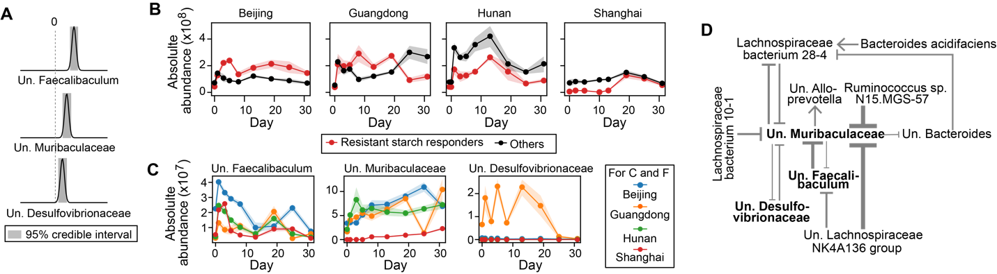

**Figure S9. (Related to Fig. 3) Inferring bacterial responders to resistant starch intervention and associated ecological interaction network.** The same figure legend applies as in the main text Fig. 3C-H (the same order).

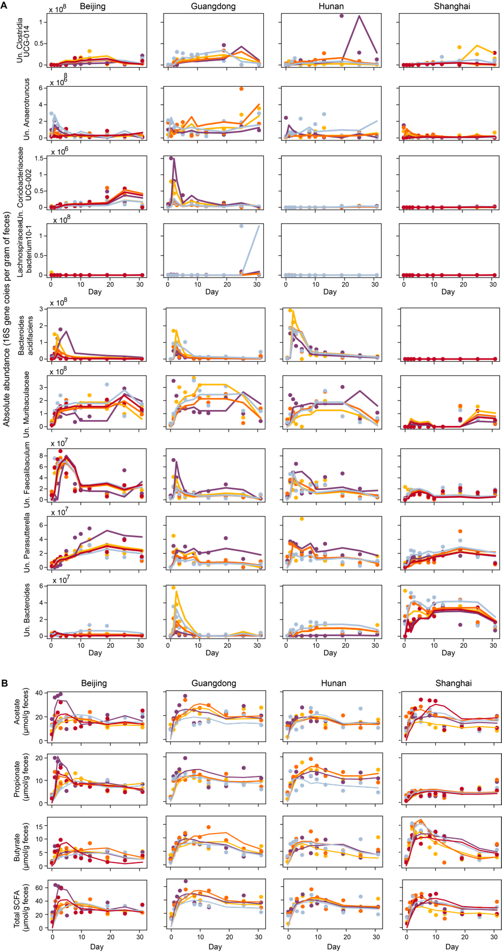

**Figure S11. (Related to Fig. 4) Reconstructed time series (lines) of selected bacterial species (A) and short-chain fatty acids (B) in the main text Fig. 4 using the first two factors of sequential Non-negative matrix factorization.** Dots represent observations and both lines and dots are color-coded on a per-mouse basis.

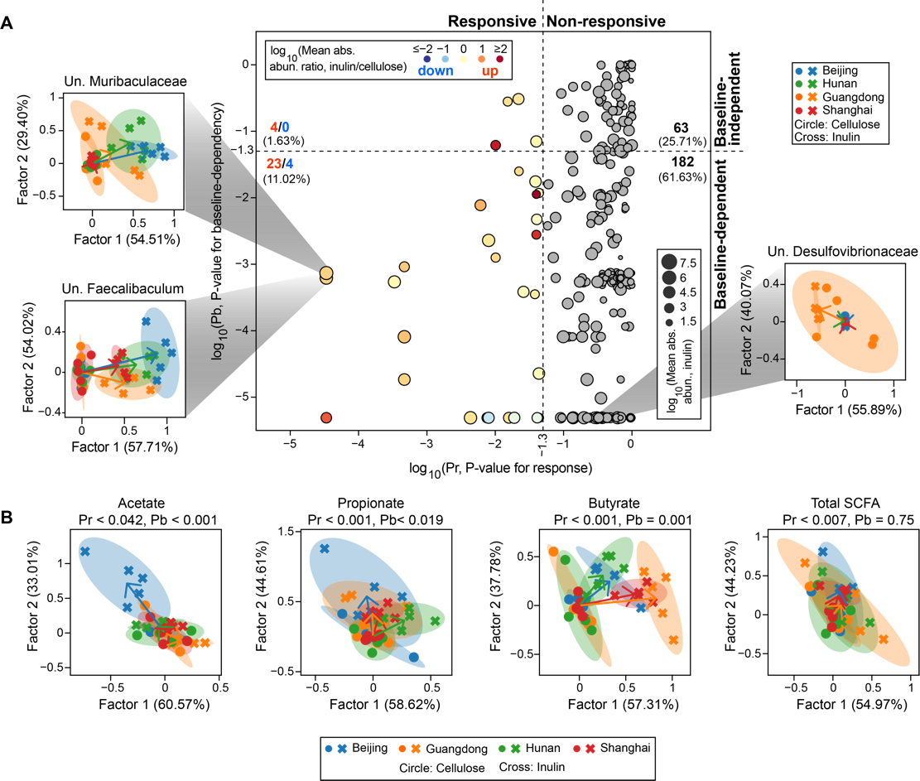

**Figure S12. (Related to Fig. 4) Individualized response analysis of bacterial species (A) and short-chain fatty acids (B) for resistant starch intervention.** The same figure legend applies as in the main text Fig. 4.

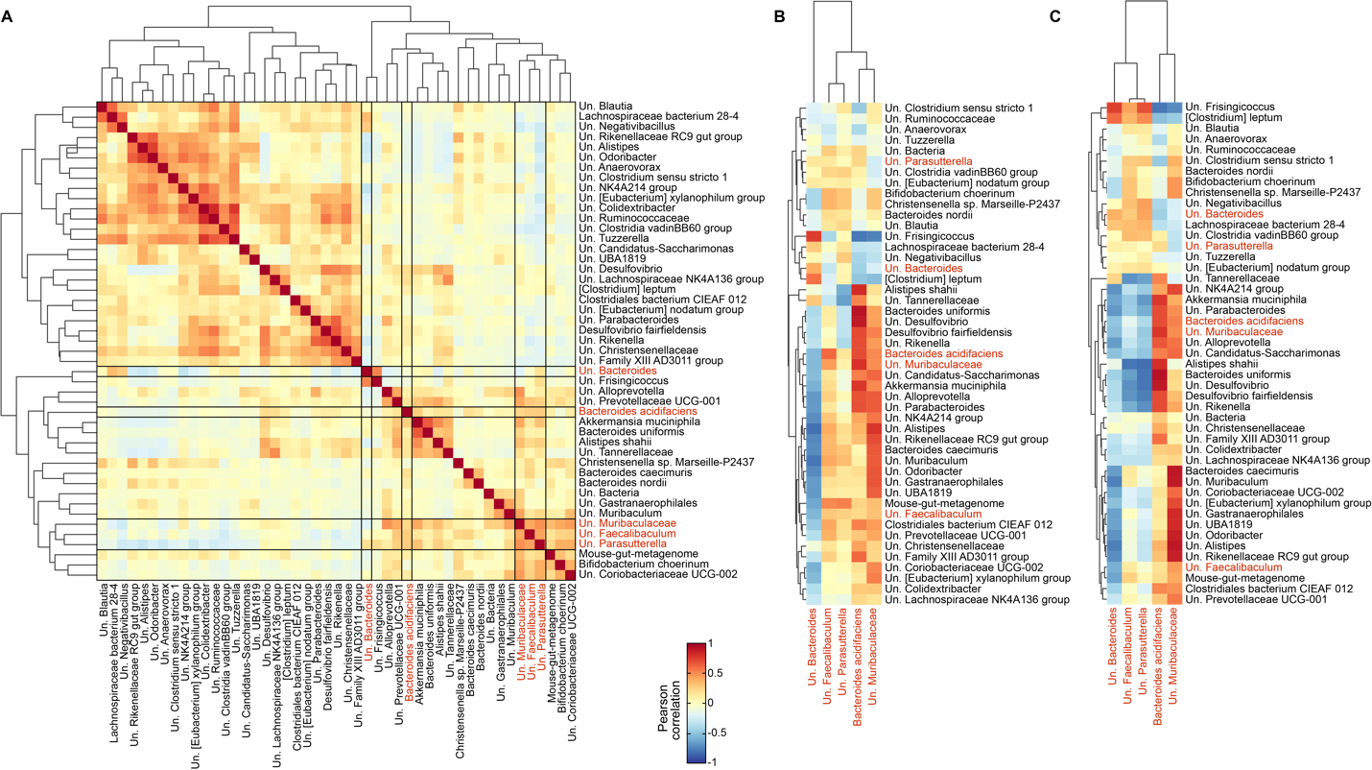

**Figure S13. (Related to Fig. 4) Pearson correlation between species w/ baseline-dependent responses (identified in the main text Fig. 4A) and inulin responders (identified in the main text Fig. 3C, highlighted in red). A**. Correlations were performed using absolute abundances at all time points. **B**,**C**. Correlations were performed using baseline absolute (B) or relative (C) abundances for species w/ baseline-dependent responses and total area under the curve of absolute abundances for inulin responders.

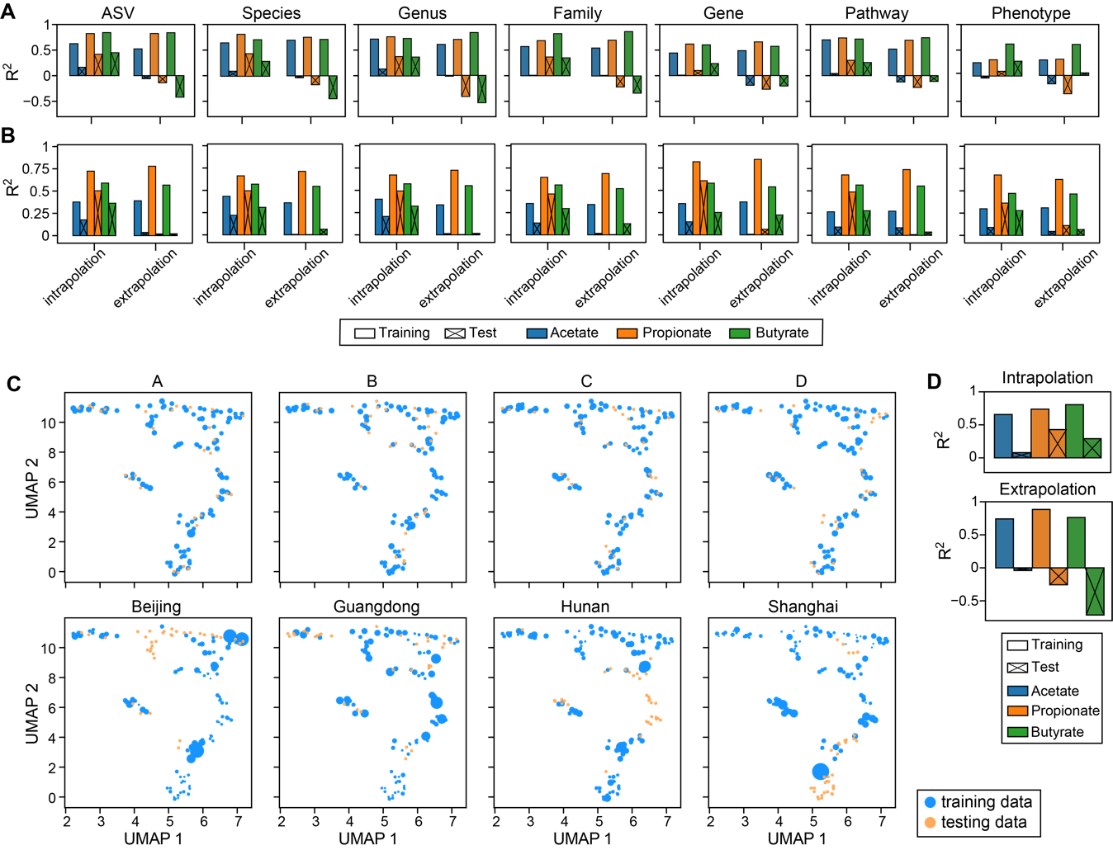

**Figure S14. (Related to Fig. 5) Poor performance of random forest model in predicting short-chain fatty acids (SCFAs) concentration (see Fig. 5B of the main text for results) cannot be rescued by using (A) alternative predictors, (B) alternative regression models, and (C,D) weighting of training samples. A**. Prediction accuracy using random forest regression model and taxonomic (ASV, Species, Genus, Family) or functional (Gene, Pathway, Phenotype) representation of gut microbiota as predictors. The abundances of genes, pathways and phenotypes were predicted using PICRUSt2. **B**. Prediction accuracy using MelonnPan and the same predictors as used in panel A. **C**. Sample weights under different data-splitting strategies. The weights of training samples closer to their corresponding test samples were assigned higher values, as indicated by larger circle sizes in a reduced two-dimensional UMAP (Uniform Manifold Approximation and Projection) space.The sample weight was calculated as 1/Pi-1, where Pi is the probability of sample i belonging to the training distribution and was estimated using random forest classifier (the same approach was applied to generate Receiver Operating Characteristics curves in Fig. 5D of the main text; see Methods in the main text for details). **D**. Prediction accuracy using random forest regression model built from weighted training data and absolute abundances of bacterial species as predictors.

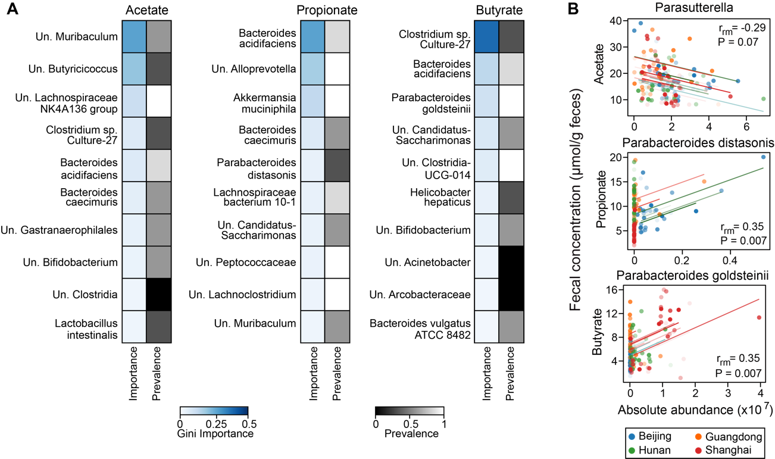

**Figure S15. Inferred short-chain fatty acid (SCFA) producers in inulin-treated mice vary depending on the inference approaches (Random forest regression vs. Repeated correlation analysis). A.** Random forest (RF) regression. For each SCFA, we showed top 10 bacterial species with the highest Gini importance score in model training using all data. The absolute abundances of bacterial species were standardized and filtered (threshold 10-5) by LASSO (least absolute shrinkage and selection operator) regression before passing to RF model. Several key hyperparameters in LASSO and RF were optimized using grid search cross-validation with R2 as the score metric. The vendor-level prevalence scores were obtained from Fig. 5C in the main text. **B**. Repeated correlation analysis. Longitudinal data and correlation trend lines are color-coded on a per-mouse basis. Repeated measures correlation coefficients (*r*rm) and FDR-corrected P-values are indicated in the plot.

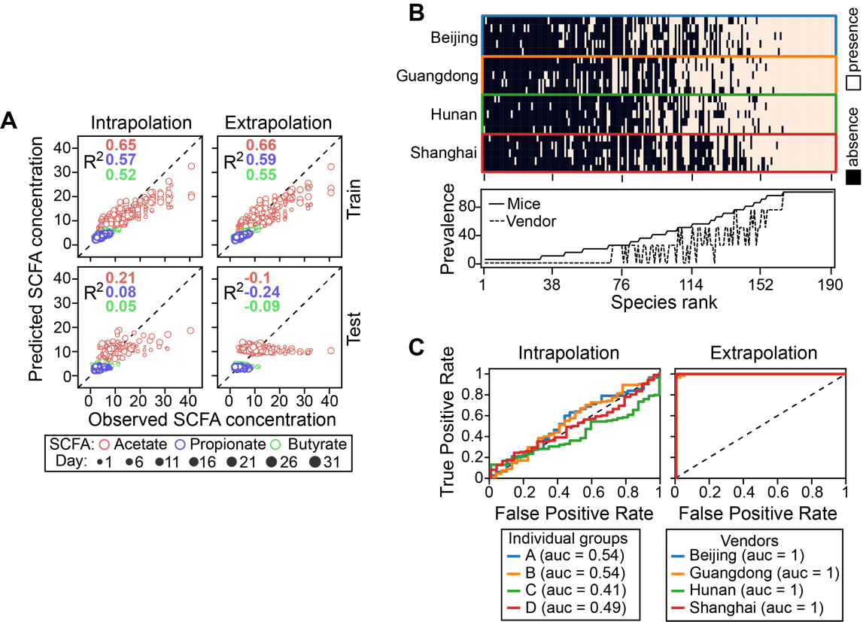

**Figure S16 (Related to Fig. 5) Prediction of short-chain fatty acid (SCFA) concentration from gut microbiota using data from resistant starch-treated mice**. The same figure legend applies as in the main text Fig. 5B-D (the same order).

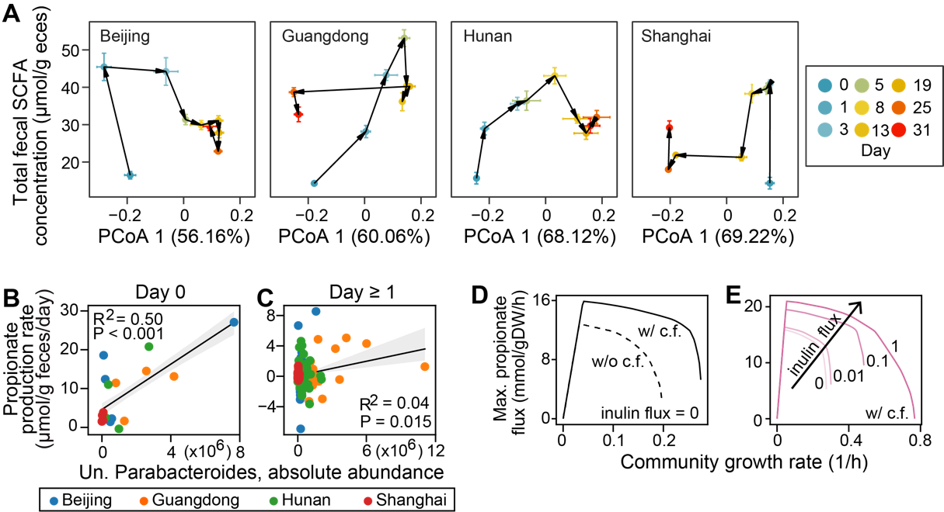

**Figure S17**. **(Related to Discussion)** The quantitative microbiome-metabolome relationship varies in a complex, time-dependent manner. **A**. Dynamics of gut microbiota composition (x-axis) and total SCFA concentration (y-axis) plotted on the same graph. We used the first principal coordinate score from PCoA (principal coordinate analysis) ordination to represent changes in gut microbiota composition (relative abundance) along the direction of maximum variance. Note that SCFA were substantially produced between day 0 and day 1, while gut microbiota composition only changes slightly. Points represent the mean PCoA scores across mice within each vendor and error bars represent the standard error of the mean. **B**-**E**. Potential producers and cross-feeding relationships for initial propionate production within a day of inulin treatment. **B**,**C**. Correlation of baseline unclassified (Un.) Parabacteroides absolute abundance with initial propionate production rates on day 0 (B) and rates in later days (C). Gray line: linear regression (R2 and P-value are indicated in the plot); shading area: standard error of the regression. **D**,**E**. Simulated effects of cross-feeding (c.f.) (D) and inulin availability (E) on growth and propionate flux of two-genera Bacteroides-Parabacteroides community. w/ c.f.: mixing Bacteroides and Parabacteroides in 1:1 ratio; w/o c.f.: mixing Parabacteroides and its clone mate in 1:1 ratio.

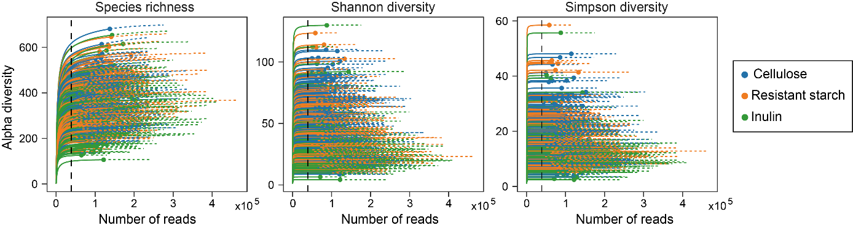

**Figure S18. (Related to Materials and Methods) Rarefaction analysis of 16S rRNA gene clone libraries in terms of species richness, Shannon diversity, and Simpson diversity.** Rarefaction curves were generated using the iNEXT package. Solid lines represent the observed alpha diversity with the number of reads sampled, and dashed lines represent the extrapolation of the solid lines until 25% more reads. To avoid sample-to-sample bias due to variable sequencing depth (different number of reads per sample), all samples were rarefied to 38,980 sequences (black dashed line) per sample before downstream analysis.

**References:**

[1]. Lynch, S.V. and O. Pedersen, The Human Intestinal Microbiome in Health and Disease. New England Journal of Medicine, 2016.

[2]. Sanna, S., et al., Causal relationships among the gut microbiome, short-chain fatty acids and metabolic diseases. Nature Genetics, 2019. 51(4): p. 600-605.

[3]. Nomura, M., et al., Association of Short-Chain Fatty Acids in the Gut Microbiome With Clinical Response to Treatment With Nivolumab or Pembrolizumab in Patients With Solid Cancer Tumors. JAMA Network Open, 2020. 3(4): p. e202895.

[4]. Gentile, C.L. and T.L. Weir, The gut microbiota at the intersection of diet and human health. Science, 2018. 362(6416

): p. 776

-780

.

[5]. Wargo, J.A., Modulating gut microbes. Science, 2020. 369(6509): p. 1302-1303.

[6]. Harkins, C.P., H.H. Kong and J.A. Segre, Manipulating the Human Microbiome to Manage Disease. JAMA, 2019. 323(4): p. 303.

[7]. Gehrig, J.L., et al., Effects of microbiota-directed foods in gnotobiotic animals and undernourished children. Science, 2019. 365(6449): p. eaau4732.

[8]. Zhao, L., et al., Gut bacteria selectively promoted by dietary fibers alleviate type 2 diabetes. Science, 2018. 359(6380): p. 1151-1156.

[9]. Valcheva, R., et al., Inulin-type fructans improve active ulcerative colitis associated with microbiota changes and increased short-chain fatty acids levels. Gut Microbes, 2019. 10(3): p. 334-357.

[10]. Rakoff-Nahoum, S., M.J. Coyne and L.E. Comstock, An Ecological Network of Polysaccharide Utilization among Human Intestinal Symbionts. Current Biology, 2014. 24(1): p. 40-49.

[11]. Solden, L.M., et al., Interspecies cross-feeding orchestrates carbon degradation in the rumen ecosystem. Nature Microbiology, 2018. 3(11): p. 1274-1284.

[12]. Falony, G., et al., Cross-Feeding between Bifidobacterium longum BB536 and Acetate-Converting, Butyrate-Producing Colon Bacteria during Growth on Oligofructose. Applied and Environmental Microbiology, 2006. 72(12): p. 7835-7841.

[13]. Creswell, R., et al., High-resolution temporal profiling of the human gut microbiome reveals consistent and cascading alterations in response to dietary glycans. Genome Medicine, 2020. 12(1).

[14]. Kolodziejczyk, A.A., D. Zheng and E. Elinav, Diet-microbiota interactions and personalized nutrition. Nat Rev Microbiol, 2019. 17(12): p. 742-753.

[15]. Cockburn, D.W. and N.M. Koropatkin, Polysaccharide Degradation by the Intestinal Microbiota and Its Influence on Human Health and Disease. J Mol Biol, 2016. 428(16): p. 3230-3252.

[16]. Ze, X., et al., Ruminococcus bromii is a keystone species for the degradation of resistant starch in the human colon. ISME J, 2012. 6(8): p. 1535-43.

[17]. Salonen, A., et al., Impact of diet and individual variation on intestinal microbiota composition and fermentation products in obese men. ISME J, 2014. 8(11): p. 2218-30.

[18]. Ahmed, W. and S. Rashid, Functional and therapeutic potential of inulin: A comprehensive review. Crit Rev Food Sci Nutr, 2019. 59(1): p. 1-13.

[19]. Cerqueira, F.M., et al., Starch Digestion by Gut Bacteria: Crowdsourcing for Carbs. Trends in Microbiology, 2019.

[20]. Martino, C., et al., A Novel Sparse Compositional Technique Reveals Microbial Perturbations. mSystems, 2019. 4(1).

[21]. Belzer, C., et al., Microbial Metabolic Networks at the Mucus Layer Lead to Diet-Independent Butyrate and Vitamin B12 Production by Intestinal Symbionts. mBio, 2017. 8(5).

[22]. Chijiiwa, R., et al., Single-cell genomics of uncultured bacteria reveals dietary fiber responders in the mouse gut microbiota. Microbiome, 2020. 8(1): p. 5-14

.

[23]. Rakoff-Nahoum, S., K.R. Foster and L.E. Comstock, The evolution of cooperation within the gut microbiota. Nature, 2016. 533(7602): p. 255-259.

[24]. Koropatkin, N.M., E.A. Cameron and E.C. Martens, How glycan metabolism shapes the human gut microbiota. Nat Rev Microbiol, 2012. 10(5): p. 323-35.

[25]. Baxter, N.T., et al., The Glucoamylase Inhibitor Acarbose Has a Diet-Dependent and Reversible Effect on the Murine Gut Microbiome. mSphere, 2019. 4(1).

[26]. Walker, A.W., et al., Dominant and diet-responsive groups of bacteria within the human colonic microbiota. ISME J, 2011. 5(2): p. 220-30.

[27]. David, L.A., et al., Diet rapidly and reproducibly alters the human gut microbiome. Nature, 2014. 505(7484): p. 559-63.

[28]. Hiel, S., et al., Effects of a diet based on inulin-rich vegetables on gut health and nutritional behavior in healthy humans. Am J Clin Nutr, 2019. 109(6): p. 1683-1695.

[29]. Wu, G.D., et al., Linking long-term dietary patterns with gut microbial enterotypes. Science, 2011. 334(6052): p. 105-8.

[30]. Nordgaard, I., et al., Colonic production of butyrate in patients with previous colonic cancer during long-term treatment with dietary fibre (Plantago ovata seeds). Scand J Gastroenterol, 1996. 31(10): p. 1011-20.

[31]. Dogra, S.K., J. Doré and S. Damak, Gut Microbiota Resilience: Definition, Link to Health and Strategies for Intervention. Frontiers in Microbiology, 2020. 11.

[32]. Fragiadakis, G.K., et al., Long-term dietary intervention reveals resilience of the gut microbiota despite changes in diet and weight. The American Journal of Clinical Nutrition, 2020.

[33]. Korem, T., et al., Bread Affects Clinical Parameters and Induces Gut Microbiome-Associated Personal Glycemic Responses. Cell Metab, 2017. 25(6): p. 1243-1253.e5.

[34]. Zhu, L., et al., Inulin with different degrees of polymerization modulates composition of intestinal microbiota in mice. FEMS Microbiology Letters, 2017. 364(10).

[35]. Li, L., et al., Inulin with different degrees of polymerization protects against diet-induced endotoxemia and inflammation in association with gut microbiota regulation in mice. Scientific reports, 2020. 10(1): p. 978-12.

[36]. Lagkouvardos, I., et al., Sequence and cultivation study of Muribaculaceae reveals novel species, host preference, and functional potential of this yet undescribed family. Microbiome, 2019. 7(1).

[37]. Le Bastard, Q., et al., The effects of inulin on gut microbial composition: a systematic review of evidence from human studies. European Journal of Clinical Microbiology & Infectious Diseases, 2019.

[38]. Scott, K.P., et al., Prebiotic stimulation of human colonic butyrate-producing bacteria and bifidobacteria, in vitro. FEMS Microbiol Ecol, 2014. 87(1): p. 30-40.

[39]. Hugenholtz, F. and W.M. de Vos, Mouse models for human intestinal microbiota research: a critical evaluation. Cellular and Molecular Life Sciences, 2017.

[40]. Lim, R., et al., Large-scale metabolic interaction network of the mouse and human gut microbiota. Scientific Data, 2020. 7(1).

[41]. Schloss, P.D., Identifying and Overcoming Threats to Reproducibility, Replicability, Robustness, and Generalizability in Microbiome Research. mBio, 2018. 9(3).

[42]. Zhang, S., H. Wang and M. Zhu, A sensitive GC/MS detection method for analyzing microbial metabolites short chain fatty acids in fecal and serum samples. Talanta, 2019. 196: p. 249-254.

[43]. Jian, C., et al., Quantitative PCR provides a simple and accessible method for quantitative microbiota profiling. PLOS ONE, 2020. 15(1): p. e0227285.

[44]. Gohl, D.M., et al., Systematic improvement of amplicon marker gene methods for increased accuracy in microbiome studies. Nature Biotechnology, 2016. 34(9): p. 942-949.

[45]. Bolyen, E., et al., Reproducible, interactive, scalable and extensible microbiome data science using QIIME 2. Nat Biotechnol, 2019. 37(8): p. 852-857.

[46]. Davis, N.M., et al., Simple statistical identification and removal of contaminant sequences in marker-gene and metagenomics data. Microbiome, 2018. 6(1).

[47]. Hsieh, T.C., K.H. Ma and A. Chao, iNEXT: an R package for rarefaction and extrapolation of species diversity (H ill numbers). Methods in Ecology and Evolution, 2016. 7(12): p. 1451-1456.

[48]. Wood, D.E., J. Lu and B. Langmead, Improved metagenomic analysis with Kraken 2. Genome Biology, 2019. 20(1).

[49]. Nurk, S., et al., metaSPAdes: a new versatile metagenomic assembler. Genome Res, 2017. 27(5): p. 824-834.

[50]. Zhao, Z., F. Baltar and G.J. Herndl, Linking extracellular enzymes to phylogeny indicates a predominantly particle-associated lifestyle of deep-sea prokaryotes. Science advances, 2020. 6(16): p. eaaz4354.

[51]. Hyatt, D., et al., Prodigal: prokaryotic gene recognition and translation initiation site identification. BMC Bioinformatics, 2010. 11: p. 119.

[52]. Fu, L., et al., CD-HIT: accelerated for clustering the next-generation sequencing data. Bioinformatics, 2012. 28(23): p. 3150-2.

[53]. Clausen, P.T.L.C., F.M. Aarestrup and O. Lund, Rapid and precise alignment of raw reads against redundant databases with KMA. BMC Bioinformatics, 2018. 19(1).

[54]. Zhang, H., et al., dbCAN2: a meta server for automated carbohydrate-active enzyme annotation. Nucleic Acids Research, 2018. 46(W1): p. W95-W101.

[55]. Nissen, J.N., et al., Improved metagenome binning and assembly using deep variational autoencoders. Nature Biotechnology, 2021.

[56]. Parks, D.H., et al., CheckM: assessing the quality of microbial genomes recovered from isolates, single cells, and metagenomes. Genome Res, 2015. 25(7): p. 1043-55.

[57]. Chaumeil, P.A., et al., GTDB-Tk: a toolkit to classify genomes with the Genome Taxonomy Database. Bioinformatics, 2019.

[58]. Stewart, R.D., et al., Open prediction of polysaccharide utilisation loci (PUL) in 5414 public Bacteroidetes genomes using PULpy. bioRxiv, 2018: p. 421024.

**校对报告**

当前使用的样式是 [Numbered(Multilingual)]

当前文档包含的题录共68条

有23条题录存在必填字段内容缺失的问题

参考文献 [1] ：字段(卷)内容缺失;

字段(期)内容缺失;

字段(页码)内容缺失;

参考文献 [13] ：字段(页码)内容缺失;

参考文献 [19] ：字段(卷)内容缺失;

字段(期)内容缺失;

字段(页码)内容缺失;

参考文献 [21] ：字段(页码)内容缺失;

参考文献 [25] ：字段(页码)内容缺失;

参考文献 [31] ：字段(期)内容缺失;

字段(页码)内容缺失;

参考文献 [32] ：字段(卷)内容缺失;

字段(期)内容缺失;

字段(页码)内容缺失;

参考文献 [34] ：字段(页码)内容缺失;

参考文献 [36] ：字段(页码)内容缺失;

参考文献 [37] ：字段(卷)内容缺失;

字段(期)内容缺失;

字段(页码)内容缺失;

参考文献 [39] ：字段(卷)内容缺失;

字段(期)内容缺失;

字段(页码)内容缺失;

参考文献 [40] ：字段(页码)内容缺失;

参考文献 [41] ：字段(页码)内容缺失;

参考文献 [42] ：字段(期)内容缺失;

参考文献 [46] ：字段(页码)内容缺失;

参考文献 [20] ：字段(页码)内容缺失;

字段(页码)内容缺失;

参考文献 [48] ：字段(页码)内容缺失;

参考文献 [51] ：字段(期)内容缺失;

参考文献 [53] ：字段(页码)内容缺失;

参考文献 [55] ：字段(卷)内容缺失;

字段(期)内容缺失;

字段(页码)内容缺失;

参考文献 [57] ：字段(卷)内容缺失;

字段(期)内容缺失;

字段(页码)内容缺失;

参考文献 [58] ：字段(卷)内容缺失;

字段(期)内容缺失;